

Peer Tutoring Platform
Design Document

Due before 5pm 13/02/2026
South East Technological University Carlow

Written By
Student Name: Temur Rustamov
Student Number: C00280204
Student Email: C00280204@setu.ie

Supervised By
Lecturer Name: Jamal Tauseef
Email: Jamal.Tauseef@setu.ie

Table of Contents
1. Abstract 5
2. Introduction 5
3. Final System Overview 5
3.1 System Architecture 5
3.2 Core Functional Components 6
3.2.1 Authentication and User Management 6
3.2.2 Post and Collaboration Module 6
3.2.3 Messaging System 6
3.2.4 Scheduling and Meetings 6
3.2.5 Rating and Gamification 6
3.2.6 Administration 6
3.3 System Deployment Overview 7
4. Technical Implementation 7
4.1 Architecture and Design Decisions 7
4.2 Module Implementation 7
4.2.1 Authentication and Authorization 7
4.2.2 User Profiles and Points System 8
4.2.3 Posts, Comments, Likes 8
4.2.4 Real-Time Messaging 8
4.2.5 Scheduling and Meetings 8
4.2.6 Notifications 8
4.2.7 Reports 9
4.3 Data Structures and Database Design 9
4.3.1 User Collection 9
4.3.2 Post and Comment Collections 9
4.3.3 Conversation and Message Collection 9
4.3.4 Meeting Collection 9
4.3.5 Notification and Report Collections 9
4.3.6 Key Schema Relationships 10
4.4 API and Backend Route Design 10
4.5 Frontend Implementation 11
4.6 Security and Validation 12
5. Testing and Evaluation 14
5.1 Overview of Testing Strategy 14
5.2 Backend Functional and Integration Testing 14
5.3 Front End-to-End Testing 14
5.4 Continuous Integration Testing 15
5.5 Reliability Evaluation 15
6. Project Reflection and Evaluation 15
6.1 Problems Encountered and Resolutions 15
6.2 What was achieved 16
6.3 What was not achieved 17
6.4 What was Learned 17
6.5 What would be done differently 18
6.6 Differences from earlier design 18
6.7 Testing Used to Assess the Reliability of the Project 19
6.7.1 Functional Testing 19
6.7.2 Security and Access Control Testing 23
6.7.3 Reliability and Validation Testing 24
6.7.4 Usability and Performance Observations 25
6.7.5 Reliability of the Final System 25
7. Reference List 25
8. Glossary 26
9. Appendix 27
Appendix A: Frontend Playwright Test Evidence 27
Appendix B: Backend Jest Test Evidence 28
Appendix C: Github Actions CI/CD Workflow 29

Table of Tables
Table 1: Frontend Functional Test Cases 18
Table 2: Backend Functional Test Cases 19
Table 3: Security and Access Control Test Cases 21
Table 4: Reliability and Validation Test Cases 22

Table of Figures
Figure A.1: Github Actions running frontend Playwright tests successfully 25
Figure A.2: Playwright HTML report overview 25
Figure B.3: Github Actions running backend Jest tests successfully 26
Figure C.4: Github Actions workflow showing all checks including Backend Tests, Deployment to AWS EC2 and Frontend tests have passed after a commit to main branch 27
Figure C.5: Github Actions workflow showing that Frontend Tests were executed successfully 28
Figure C.6: Github Actions workflow showing that Backend Tests were executed successfully 29
Figure C.7: Github Actions workflow showing that AWS EC2 Deployment was executed successfully 30

Introduction
The purpose of this document is to present the design of the Peer Tutoring Platform. It describes the architectural structure of the platform, the main database relationships, the core message sequence diagrams and the proposed user interface for the core workflows. The document also explains how the major components of the application fit all together and how the chosen design supports the functional requirements of this project.

Diagrams
This section shows the core diagrams used to describe the design of the Peer Tutoring Platform. The diagrams illustrate the overall system architecture, the main data relationships, the sequence of interactions in core workflows and the structure of the user interface. All together they form a visual representation of interaction between the major platform components.

Sequence Diagrams
This section provides sequence diagrams for core user workflows such as user registration, user login, authorization with Google OAuth, updating user profile, creating a post, commenting on post with notification, sending a friend request, accepting a friend request, creating a conversation and sending the first message to a friend, loading char history, rating meetings and transferring points, reporting inappropriate user activity, freezing users, generating presigned upload URL and uploading to AWS S3.

User Registration with automatic sign in
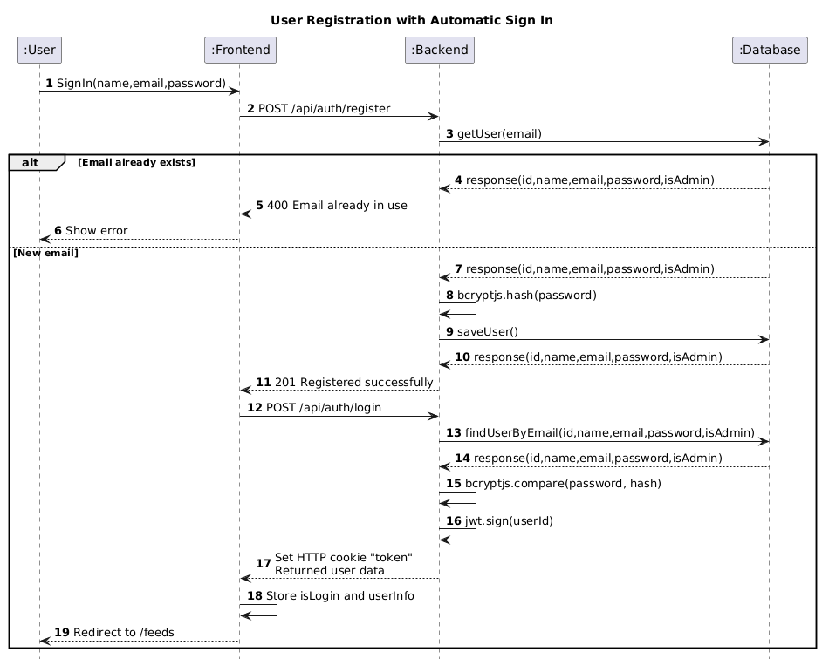
Figure 1: User registration sequence diagram
In this sequence diagram the user begins the registration process by submitting account details through the user interface. The frontend sends this data to the backend for validation and processing. Then the backend checks the database to check if the email address is already registered. If the email is unique, then the password is securely hashed and a new user record is stored in the database. After successful registration the frontend sends a separate login request. The backend then verifies the user credentials, generates a JSON Web Token, sets it in an HTTP only cookie and returns the user data after which the user is redirected into the system.

User Login
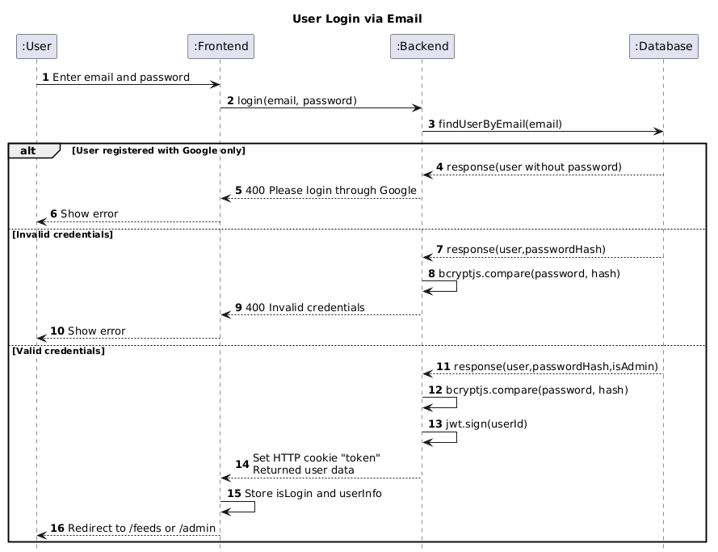
Figure 2: User Login sequence diagram
In this sequence diagram, the user enters an email address and password through the login user interface. The frontend sends the submitted data to the backend for authentication. The backend retrieves the user record from the database using the provided email address and checks whether the account is a standard email account or a Google only account. If the account is valid, then the submitted password is compared against the stored bcryptjs hash. Only when authentication succeeds, the backend generates a JSON Web Token, sets it in an HTTP only cookie and returns the user data. The frontend then stores the login state and redirects the user into the system.

Google OAuth Login
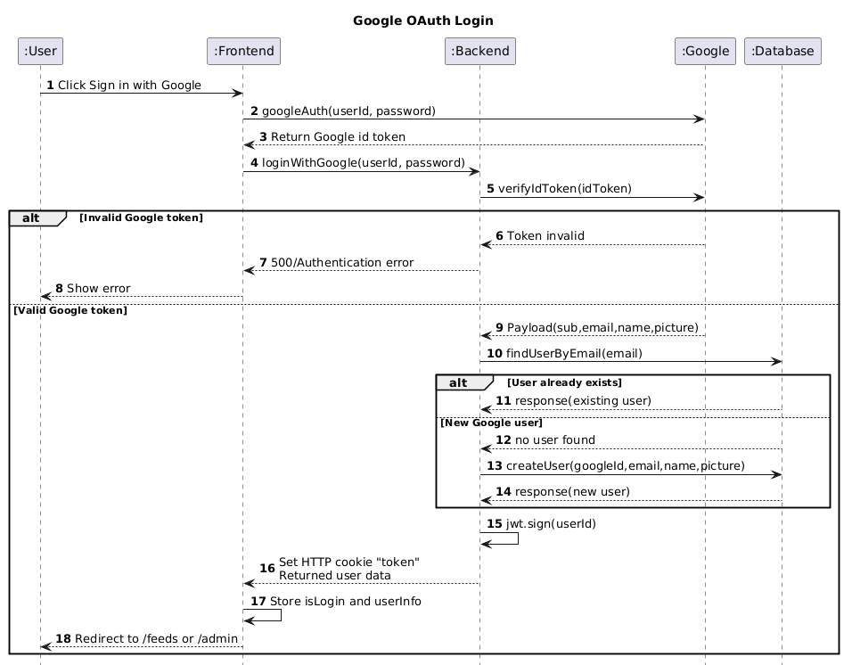
Figure 3: Authorisation through Google Login sequence diagram
In the sequence diagram above the user starts the process with choosing to sign in with Google through the user interface. The frontend requests authentication from Google and receives an ID token after successful consent. This token is then sent to the backend through the Google login endpoint. The backend verifies the token with Google and extracts the user data. It then checks the database to check if the user already exists and if the user does not exist, a new account is created using the Google profile information. Straight after that, the backend generates a JSON Web Token, sets it in an HTTP only cookie and returns the user data. Then the frontend is able to store the login state and redirect the user into the platform.

Update User Profile
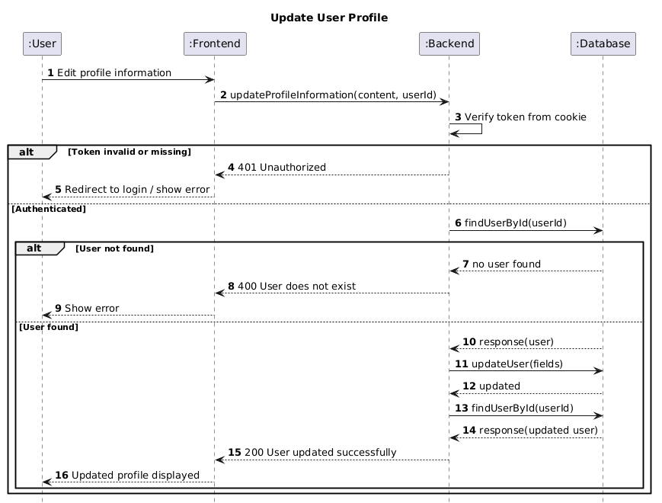
Figure 4: Update User Profile sequence diagram
As it is shown in the sequence diagram above, as the first step, the user edits profile information through the profile page. The frontend sends the updated fields to the backend through the profile update endpoint. The backend first verifies the authentication token stored in the cookie and loads the current user identity. It then checks that the user exists in the database before applying the requested changes. After the update is completed, the backend retrieves the updated user record and returns it to the frontend, allowing the revised profile information to be displayed to the user.

Create Post
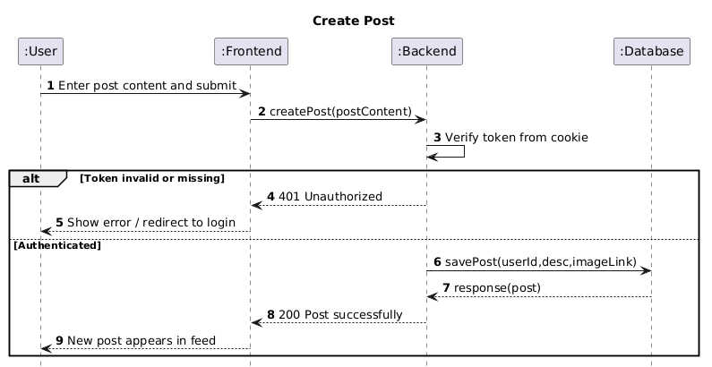
Figure 5: Create Post sequence diagram
In this sequence diagram, the user creates a new post through the feed interface by entering text and optionally attaching an image. The frontend sends the post data to the backend through the post creation endpoint. The backend verifies the user’s authentication token and then stores the new post in the database together with the author reference and content. Once the record has been saved, the backend returns the created post to the frontend, allowing it to be displayed in the feed.

Comment on Post with Notifications
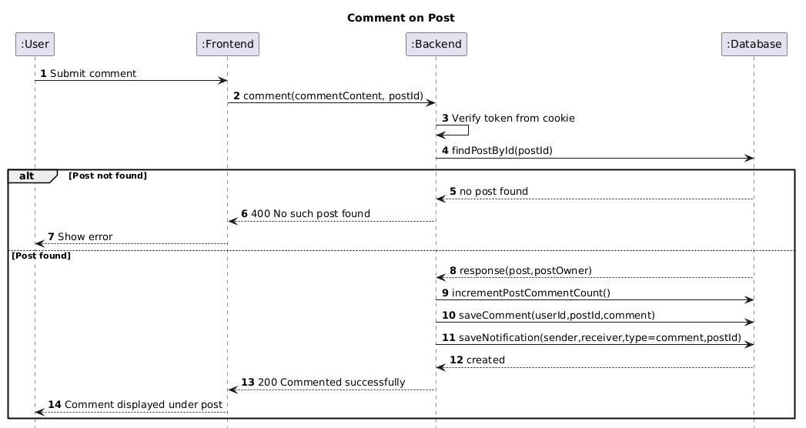
Figure 6: Commenting on Post with Notifications sequence diagram
In the diagram above, the user submits a comment on an existing post through the frontend interface. The frontend sends the post identifier and comment text to the backend. After verifying the authentication token, the backend checks that the post exists in the database. If it does, the backend increments the comment count on the post, stores the new comment record and creates a notification for the post owner. The backend then returns the created comment to the frontend so that it can be displayed beneath the post.

Sending Friend Request
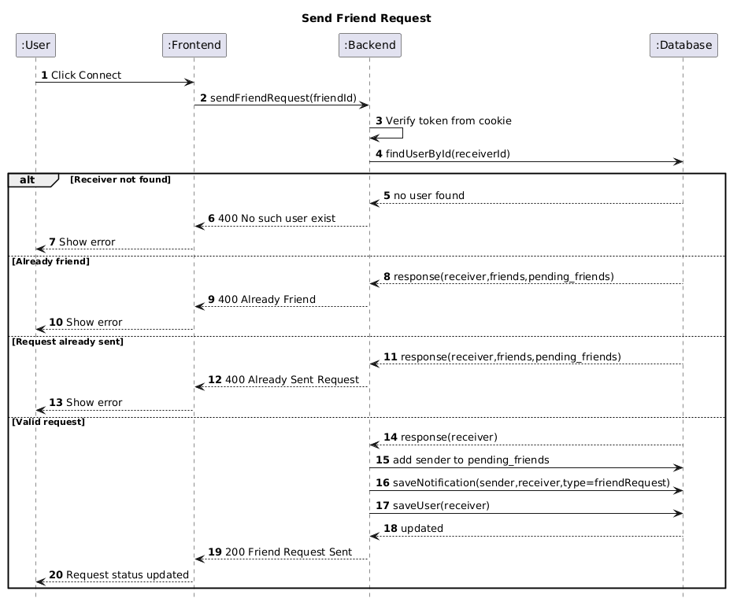
Figure 7: Sending Friend Request sequence diagram
In this sequence diagram as it is shown above, the user sends a friend request to another user through the profile interface. The frontend sends the selected receiver identifier to the backend using the friend request endpoint. The backend verifies the user’s token, loads the target user from the database and checks whether both users are already connected or whether a request has already been sent. If the request is valid, the sender is added to the target user’s pending friends list, a notification is created and the updated state is saved. The backend then confirms the action to the frontend so the interface can show that the request has been sent.

Accept Friend Request
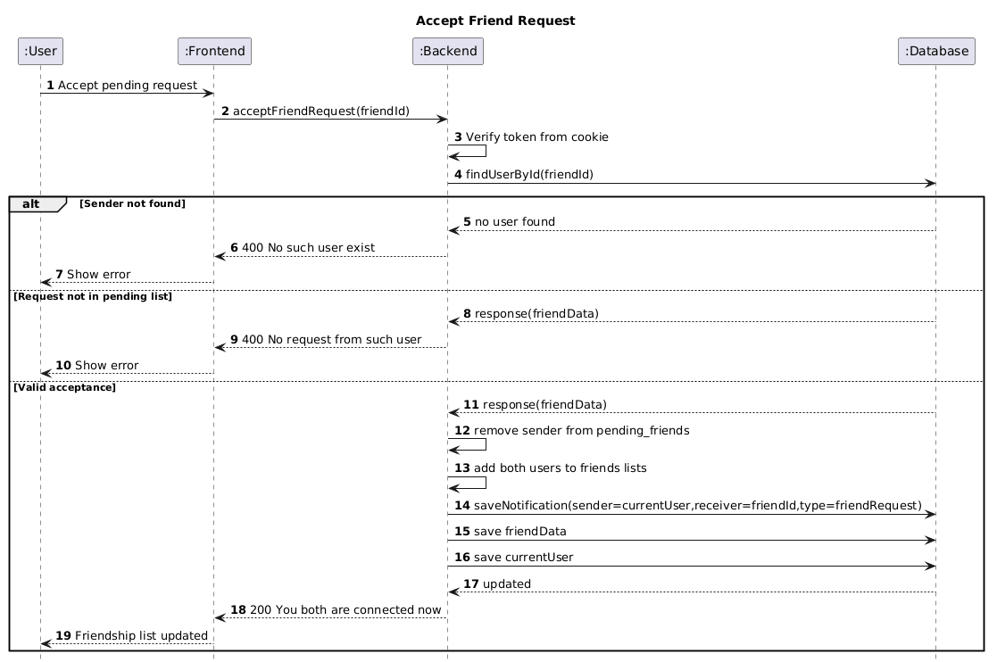
Figure 8: Accepting Friend Request sequence diagram
In the sequence diagram above, the user accepts a pending friend request through the interface for managing the network of peers. The frontend sends the sender identifier to the backend using the friend request acceptance endpoint. The backend verifies the authentication token, loads the sender from the database and confirms that the sender actually exists in the current user’s pending requests list. If the request is valid, the pending request is removed, both users are added to each other’s friends lists and a notification is created. The updated relationship is then saved and the frontend reflects the successful connection.

Create Conversation and Send the First Message
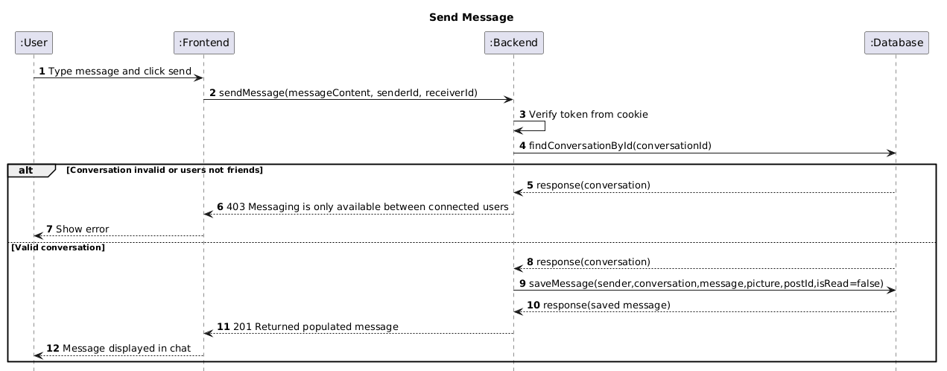
Figure 9: Creating Conversation and Sending the First Message sequence diagram
In this sequence diagram, the user sends a message through the user interface. The frontend sends the conversation identifier and message content to the backend using the message endpoint. The backend verifies the authentication token and checks that the conversation exists and that messaging is taking place between connected users. If the conversation is valid, then the new message is stored in the database with the sender reference and unread status. The created message is then returned to the frontend and displayed in the active chat.

Load Message and Mark them as Read
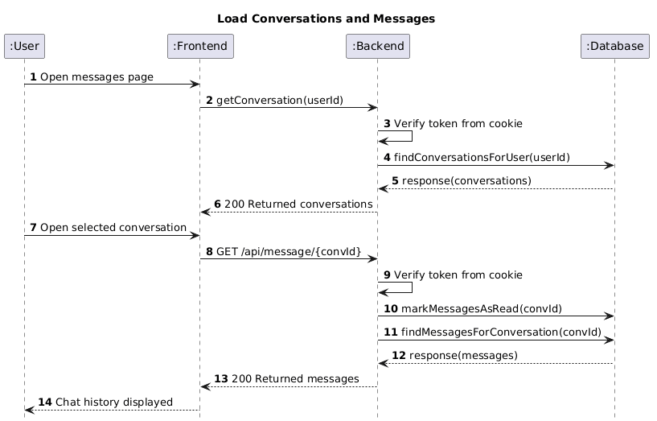
Figure 10: Loading Message and Marking them as Read
As it is shown in the sequence diagram above, the user opens the messaging page to access existing conversations. The frontend first requests the list of conversations from the backend, which verifies the authentication token and retrieves the relevant conversation records from the database. When the user selects a particular conversation, the frontend sends another request for the associated messages. The backend updates unread messages as read where necessary, retrieves the message history and returns it to the frontend so that the selected chat can be displayed.

Schedule Meeting
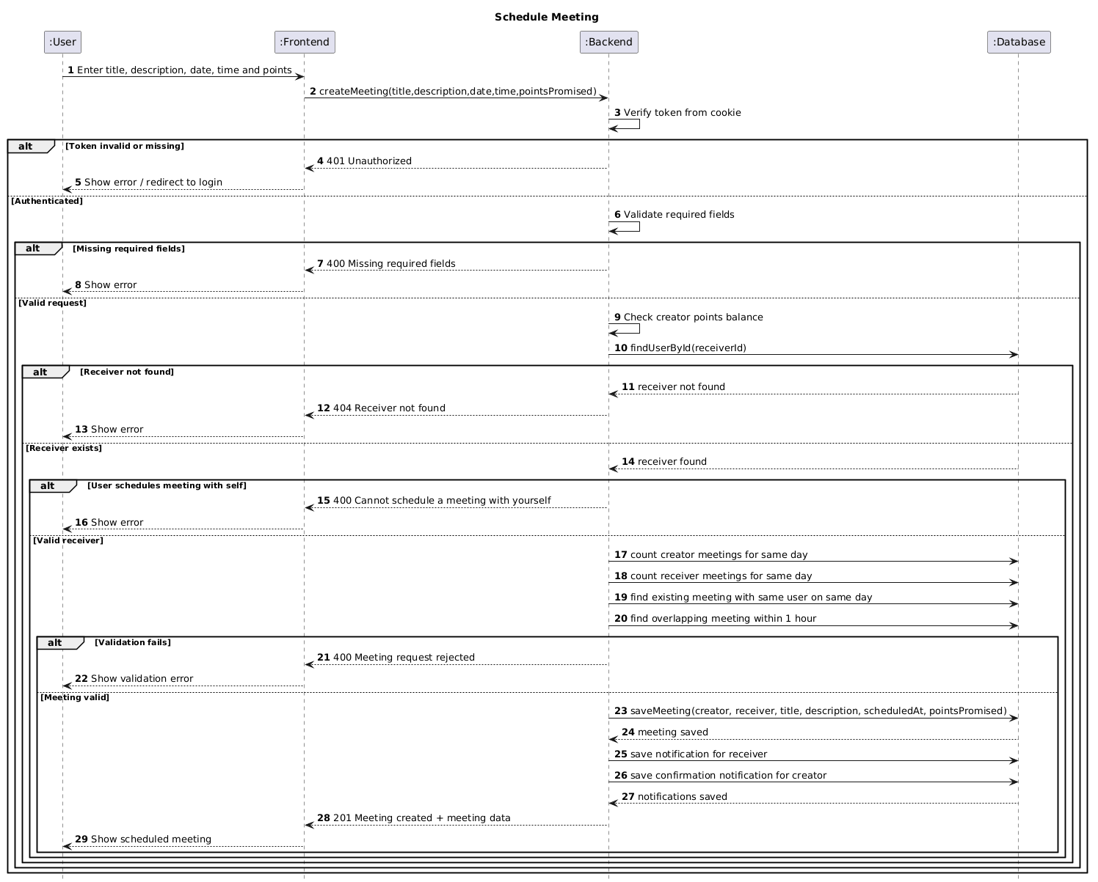
Figure 11: Scheduling Meeting sequence diagram

In this sequence diagram, the user begins the meeting scheduling process with entering the meeting details through the user interface. The frontend sends this data to the backend. Then the backend first checks the authentication token and validates that all required fields are present. It then checks that the user has enough points, ensures that the receiver exists and prevents the user from scheduling a meeting with themselves to mitigate against cheating. Straight after, the backend applies the meeting validation rules by checking the daily meeting limit for both users which prevents scheduling more than one meeting with the same user on the same day and rejecting meetings that overlap within a one hour window. If all validation checks pass, the meeting is stored in the database and notification records are created for both users. The backend then returns the created meeting data and the frontend displays the scheduled meeting to the user.

Rate Meeting and Transfer Points

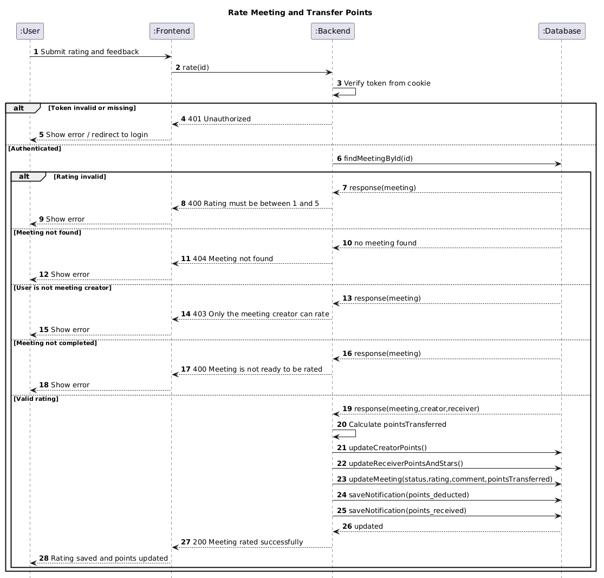
Figure 12: Rating Meeting and Transferring Points sequence diagram

In the sequence diagram above, the user submits a meeting rating and optional feedback through the user interface. The frontend sends the request to the backend using the meeting rating endpoint. The backend, as the first step, tests the authentication token and then loads the selected meeting from the database. It validates that the rating is within the allowed range, checks that the meeting exists, ensures that only the meeting creator can submit the rating and confirms that the meeting status is completed and if all conditions are satisfied, then the backend calculates the number of points to transfer, deducts points from the creator, credits the receiver, stores the rating in the receiver’s feedback data, updates the meeting record and creates notifications for both users. The backend then returns a success response so the frontend can display the updated result.

Report Content
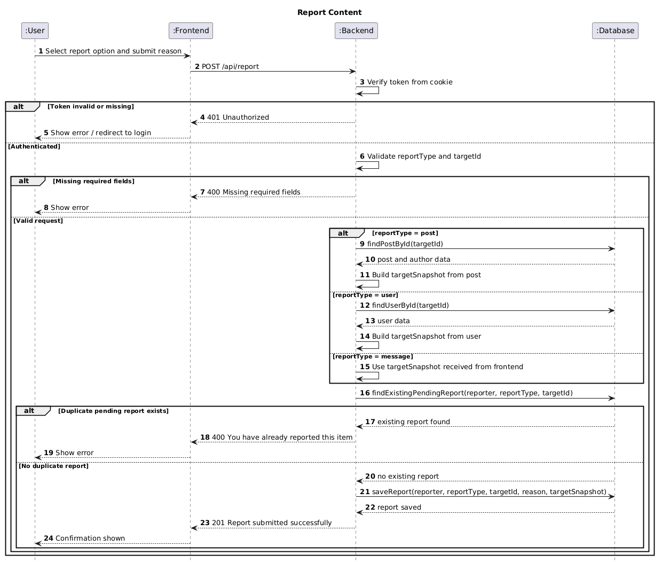
Figure 13: Reporting Content sequence diagram

In the sequence diagram as it is shown above, the user submits a report against content or another user through the frontend interface. The frontend sends the report request to the backend using the reporting endpoint. The backend first verifies the authentication token and validates that the report type and target identifier are provided and depending on the report type, the backend may retrieve the related post or user from the database in order to build a snapshot of the reported content. For message reports, the snapshot is provided by the frontend. Then the backend checks whether the same user has already submitted a pending report for the same target. If such a duplicate report exists then the request is rejected. Otherwise, a new report record is created and stored successfully. The backend then returns a success response and the frontend shows confirmation to the user.

Freeze User as Admin
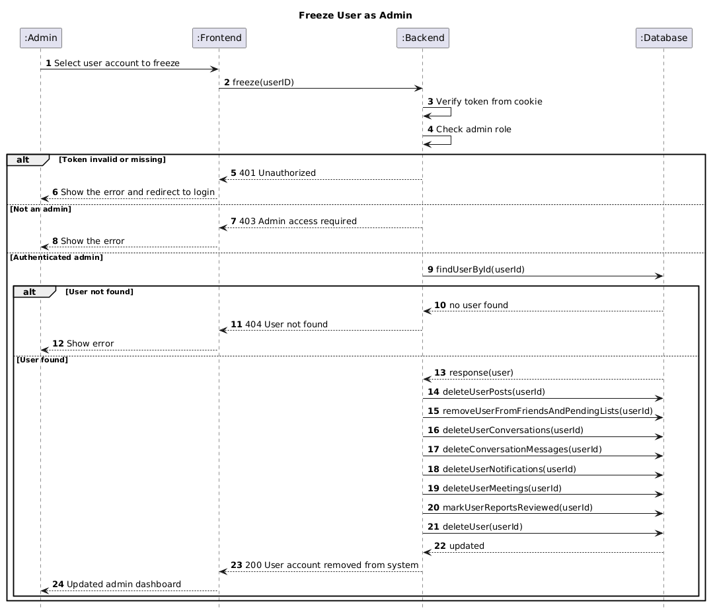
Figure 14: Freezing User Account as Admin sequence diagram

In this sequence diagram, an administrator chooses to freeze a user account through the admin dashboard given the fact that the user was reported. The frontend sends a delete request to the backend using the administrative freeze endpoint, while the backend verifies the authentication token and confirms that the requester of such action has administrator privileges. It then checks whether the target user exists in the database and if the user is found, the backend removes the user’s posts, deletes conversations and related messages, removes friendship connection with peers and pending request references from other users, deletes notifications and meetings involving that account, marks related user reports as reviewed and finally deletes the user record itself from the database. After the cleanup is completed, the backend returns a success response and the frontend updates the dashboard.

Generate Presigned Upload URL and Upload to AWS S3
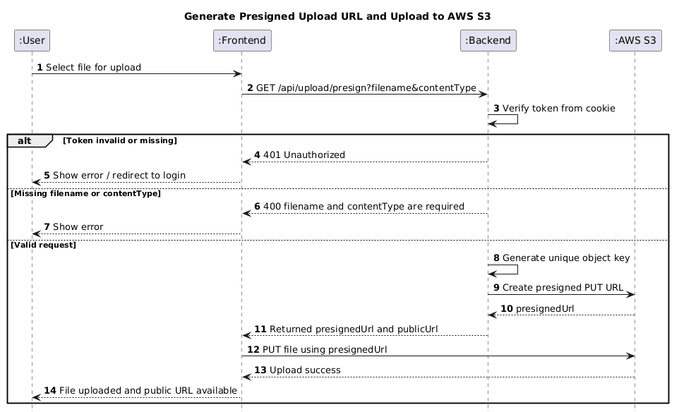
Figure 15: Generate Presigned Upload URL and Upload to AWS S3 sequence diagram

In this sequence diagram, the user selects a file through the user interface for uploading. The frontend first sends a request to the backend asking for a presigned upload URL including the file name and content type. The backend tests the authentication token and validates that the required parameters are present. If the request is valid then the backend generates a unique storage key and requests a presigned URL from AWS S3 bucket. The backend then returns both the presigned upload URL and the final public file URL to the frontend. The frontend uploads the file directly using the returned presigned URL to AWS S3 without passing the file through the application server. After the upload succeeds the frontend can use the public URL in later operations such as posts or messages as examples.

System Architecture Diagram

Figure 16: System Architecture Diagram of the Peer Tutoring Platform
As it is shown above, this system architecture diagram represents the conceptual model that defines the structure and behaviour of the system.
Peer Tutoring Platform uses a client server architecture based on the MERN stack. The frontend is implemented using React.js and Vite, the backend uses Node.js with Express.js and MongoDB provides the main database layer. Socket.io is used to support live messaging and notification updates. The cloud services such as Google OAuth 2.0 and AWS S3 are integrated externally. The architecture diagram also shows that the system is deployed within an AWS EC2 environment and accessed by both student and administrator users through a web browser.
In addition, the frontend communicates with the backend through HTTP and HTTPS requests for core features such as authentication, posts, profile management, reporting, and meeting scheduling. The backend exposes REST API endpoints and applies JWT based authentication and middleware protection for secure access to restricted resources. MongoDB stores the main application data, while AWS S3 handles file uploads through presigned URLs. This layered design improves maintainability, supports real-time communication, and provides clear separation between presentation, application, database, and external service concerns.

Entity Relationship Diagram
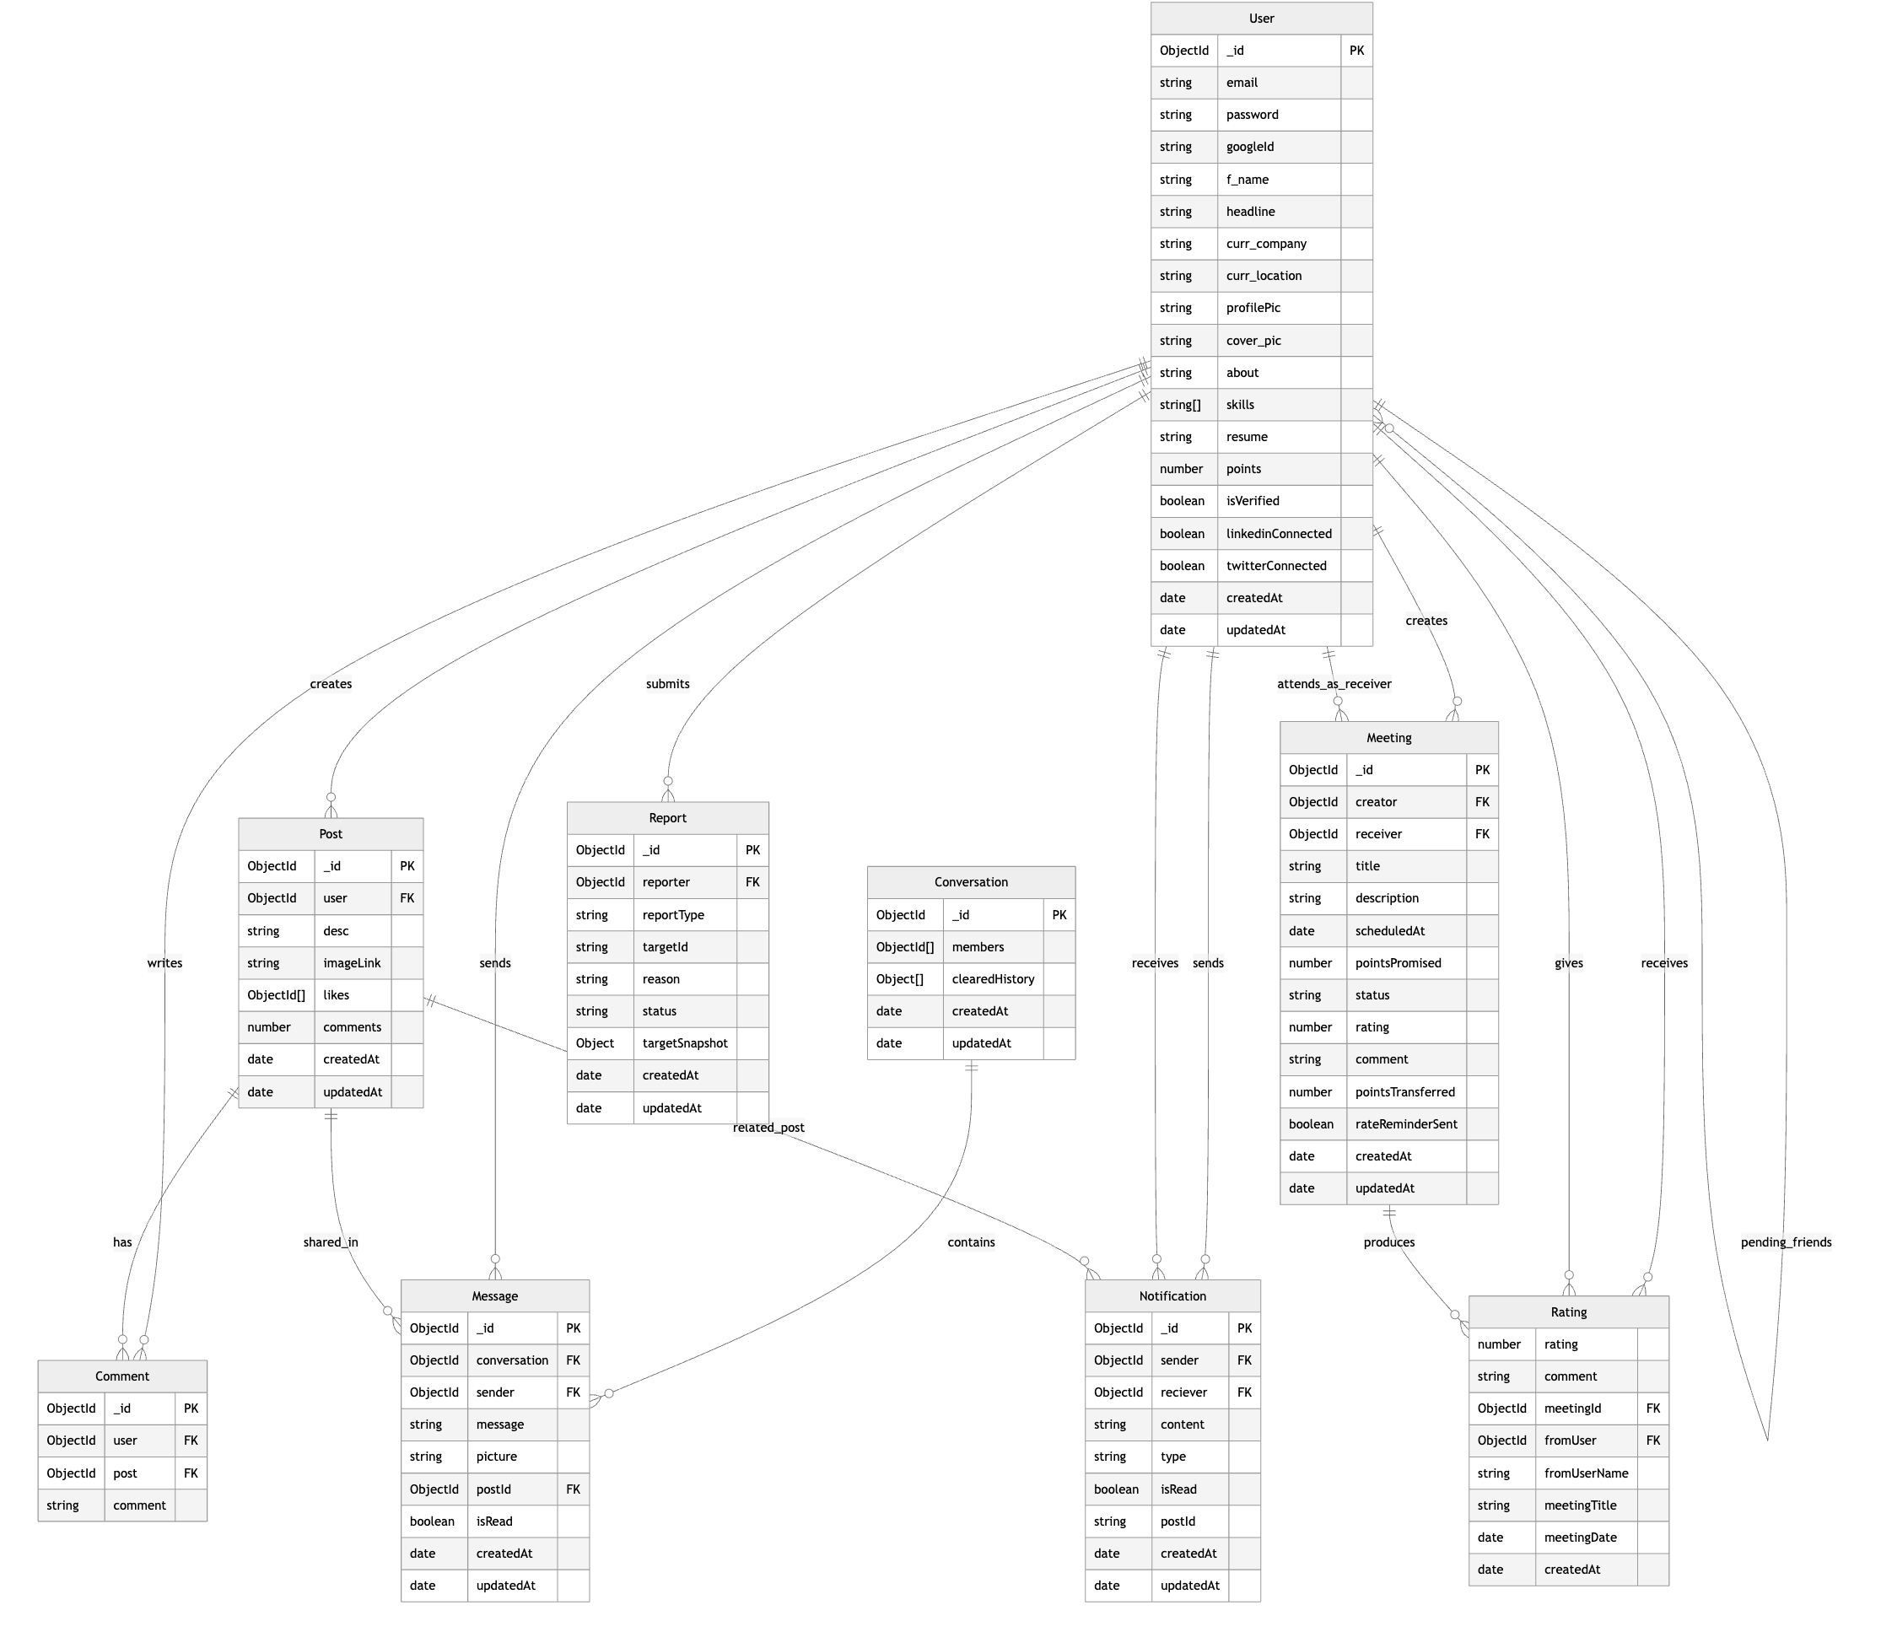
Figure 17: Entity Relationship diagram of the Peer Tutoring Platform

User to Post Relationship
The following relationship is one to many. A User can create multiple Posts, while each Post is associated with exactly one User. The relationship represents users publishing academic content such as tutoring requests, study topics or discussions.

Post to Comment Relationship
This relationship is one to many. A Post can have multiple Comments, while each Comment belongs to exactly one Post. This relationship represents discussion and feedback under posts, allowing other users to respond, ask questions and offer help.

User to Comment Relationship
The relationship is one to many. A User can create multiple Comments, while each Comment is written by exactly one User. It shows user participation in discussions and ensures that each comment is linked to its author.

User to Conversation Relationship
The relationship is many to many. A User can participate in multiple Conversations, and each Conversation can include multiple Users. This relationship models private chat interaction between users.

Conversation to Message Relationship
This relationship is one to many. A Conversation can contain multiple Messages, while each Message belongs to exactly one Conversation.

User to Message Relationship
The relationship is one to many. A User can send multiple Messages, while each Message is sent by exactly one User. It records message ownership and identifies the sender of each message.

User to Notification Relationship
This relationship is one to many. A User can be associated with multiple Notifications, while each Notification is linked to users involved in a specific system event. This relationship represents actions such as friend requests, comments, meeting updates and points transfers.

Post to Notification Relationship
The relationship is an optional one to many. A Post may be referenced by multiple Notifications, while a Notification may optionally reference a Post. This relationship exists since there are notifications like comment related activity that may refer to a particular post, while others may not.

User to User Relationship
This relationship is many to many. A User can be friends with multiple other Users and each User can also be connected to multiple other Users.

User to Meeting Relationship
This relationship is one to many. A User can be associated with multiple Meetings, either as the creator or as the receiver, while each Meeting links two specific Users.

User to Report Relationship
This relationship is one to many. A User can submit multiple Reports, while each Report is submitted by exactly one User. This relationship supports moderation by linking each report to the user who created it.

Meeting to Rating Relationship
This relationship is one to optional one. A Meeting can produce at most one Rating, while each Rating belongs to one specific Meeting.

User to Rating Relationship
This relationship is one to many. A User can receive multiple Ratings and can also give multiple Ratings through completed meetings. It supports the feedback and gamification element of the platform.

Important Algorithms and Pseudocode
The following section presents the core algorithms used in the project. The selected algorithms represent the core logic of the system since they contain the main validation rules and access control decisions. The algorithms below were implemented on the backend to ensure consistency and security of the platform behvaiour.

User Registration Algorithm
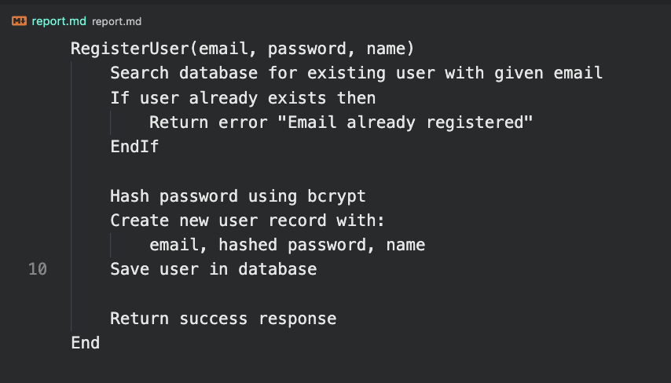
Figure 18: Pseudocode representing User Registration algorithm
The algorithm above handles new user registration. It ensures that duplicate accounts are not created and that passwords are hashed and then stored in the database before insertion.

User Login Algorithm
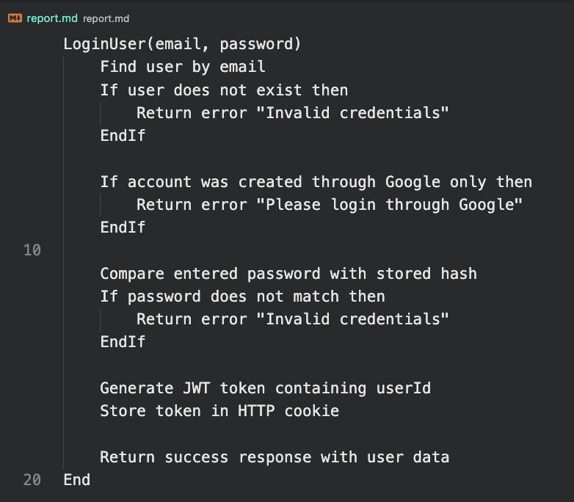
Figure 19: Pseudocode representing User Login algorithm
The algorithm above validates user credentials and created a signed JSON Web Token for authenticated access to protected routes.

JWT Authentication Middleware
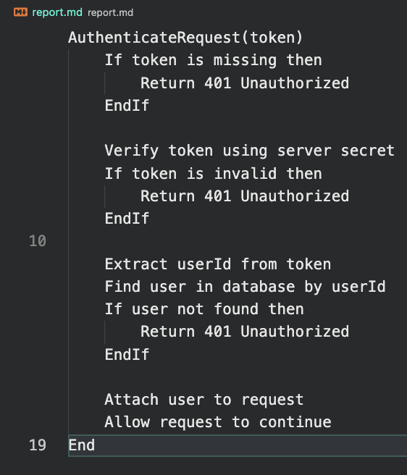
Figure 20: Pseudocode representing Authentication Middleware algorithm
This algorithm protects restricted endpoints such as posts, messaging, meetings and profile updates. It checks the token and then loads the authenticated user from the database.

Meeting Scheduling Validation Algorithm
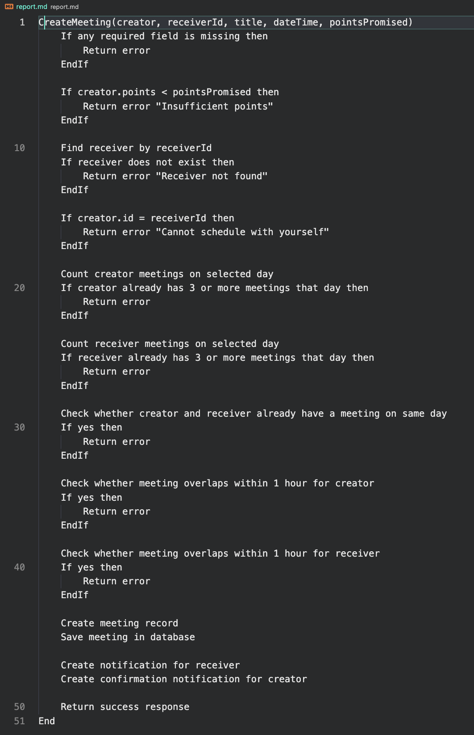
Figure 21: Pseudocode representing Meeting Scheduling Validation algorithm
The algorithm above represents how the validation logic of meeting scheduling was implemented into the project. The tutoring sessions rules prevent self-booking, booking with insufficient points, duplicate meetings on the same day and overlapping meetings. In particular, users are allowed to have no more than 3 meetings created per day and that there is an 1 hour window between tutoring sessions.

Meeting Rating and Points Transfer Algorithm
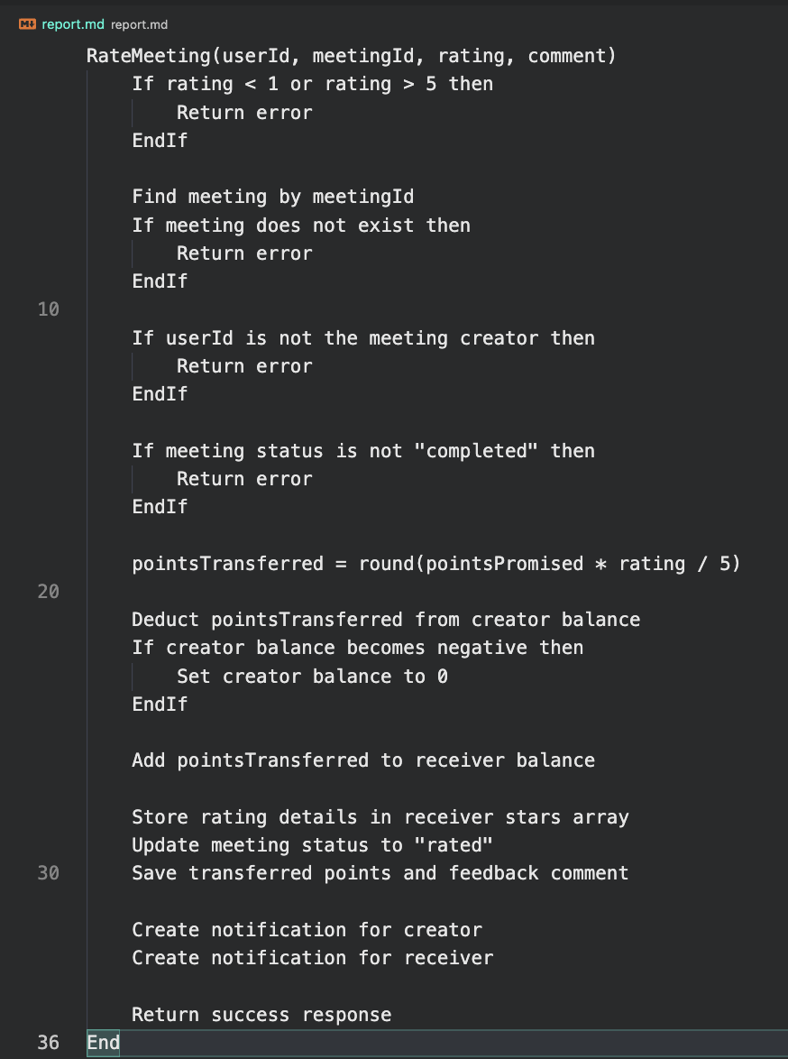
Figure 22: Pseudocode representing Meeting Rating and Points Transfer algorithm
This algorithm ensures that only the meeting creator can rate a completed meeting and prevents the creator’s points balance from becoming negative. In addition, the number of points transferred to the receiver is calculated by multiplying the rating by the points initially allocated to the tutoring session and dividing the result by 5, where 5 represents the maximum number of stars. Together they form the validation rules for meeting rating.

Freeze User Account Algorithm
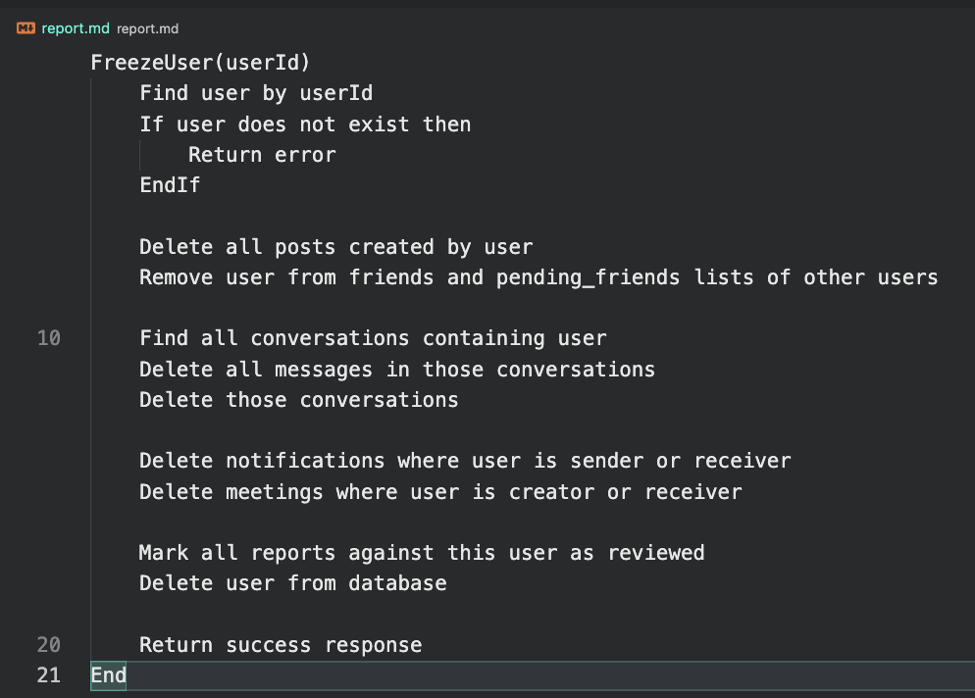
Figure 23: Pseudocode representing Freeze User Account algorithm
This algorithm, as the first step, checks whether the user exists in the database. If the user is found, the system deletes all posts created by that user, removes their identifier from other users friends and pending friends lists, then locates all conversations in which the user participated. All messages linked to those conversations are deleted, followed by the conversations themselves. The algorithm also removes notifications and meetings associated with the user, marks any reports against that user as reviewed. Finally, it deletes the user record from the database.

User Interface Design

Core Functional Components
The final system consists of the following core functional modules:

Authentication and User Management
Users can register and log in using email and password credentials. JSON Web Token authentication ensures protected access to system resources. The following fields are stored in user profiles: academic interests, introduction, accumulated points.

Post and Collaboration Module
Users can create tutoring related posts. Each post contains description, author name, comment section. Other users can interact with posts through likes or forwarding them to other chats. This module forms one of the core academic interaction layers of the platform.

Messaging System
The system includes a real time messaging feature that provides a communication layer for users. Messages are sent through WebSocket connections. This module supports chat creation with peers, real time delivery, loading of historical conversations.

Scheduling and Meetings
Users can propose tutoring sessions by selecting date and time parameters, points allocation. Meetings details are stored in the database. This module integrates notifications to remind users to rate services.

Rating and Gamification
After finishing a tutoring session, users can rate meetings on a scale from zero to five. Based on the rating given, a specific number of points is transferred from initiator’s points balance to the receiver. Ratings contribute to cumulative scores within the platform. The system promotes active participation and user engagement.

Administration
Administrators can monitor posts, messages and user activity. Moderation tools allow removing inappropriate content to ensure compliance with university standards.

System Deployment Overview
The application runs using a Node.js server environment. MongoDB stores persistent data and the frontend is served via a React server that communicates with the backend through defined API endpoints.
The system supports multiple concurrent users and maintains storage of user data, posts, messages, meetings. All communication between client and server is secured using HTTPS during deployment.

Technical Implementation
This section discusses the technical implementation of Peer Tutoring Platform. It explains the key architectural decisions, module implementations, data structures, supporting technologies used to develop the system. The purpose of this section is to demonstrate how the system was implemented and how the chosen technologies support the functional requirements in the project specification.

Architecture and Design Decisions
Peer Tutoring Platform was built with the help of the MERN stack, which includes MongoDB, Express.js, React.js and Node.js. This architectural choice enables the use of JavaScript across the entire application stack which enhances maintainability. React.js was chosen for the frontend due to its component architecture and state management capabilities. These features alone make it more efficient to render the content, which is crucial for live notifications, message updates and speeding up frontend development. Node.js was selected for the backend because of its event driven runtime model that improves supporting multiple concurrent users using the system. Express.js was chosen as a framework for defining representational state transfer (REST)* API endpoints, routing logic and middleware for authentication and request validation. MongoDB was selected as the database storage due to its document-oriented nature, which fits well with the data model of the platform and allows for future expansion of features without the limitations of a relational database. Live communication was built using WebSocket using the Socket.io library, which provides instant communication for messages and notification updates without repeated polling, hence significantly improving the user experience and reducing the network overhead.

Module Implementation
This section describes how the main functional modules of Peer Tutoring Platform were implemented across the stack. Each module maps directly to MongoDB collections and is exposed through REST API endpoints for app features. Socket.io events were used alongside persistent database storage where live updates were required to ensure reliability.

Authentication and Authorization
Authentication was implemented using email and password login with the help of JSON Web Tokens used for authentication. During registration, user credentials are validated server-side and the password is stored as a salted hash. On successful login only, the backend issues a signed JSON Web Token which the client stores and includes in the corresponding header for protected requests. The middleware verifies the token on protected routes and extracts the user ID to enforce access control. This approach ensures that only authenticated users can access restricted resources such as messaging, meeting scheduling, profile updates.

User Profiles and Points System
User profile data is stored in the corresponding collection and includes core identity fields such as name and email, profile fields and user background. Profile update endpoints validate allowed fields to prevent unintended edits. The points system updates after making each successful meeting session. Points are computed server-side to prevent manipulation and all updates persisted in MongoDB to maintain consistency.

Posts, Comments, Likes
The post module allows students to create tutoring-related requests and academic support posts. Posts are stored in the post collection with references to the author, content, timestamps, image attachments where applicable, and engagement statistics. Comments are stored in a separate comment collection and linked to both the relevant post and the user who created the comment. Likes are tracked by storing the identifiers of users who have liked a particular post, which prevents duplicate likes from the same user. This module forms one of the main academic interaction mechanisms of the platform.

Real-Time Messaging
Live messaging was built using Socket.io to support instant communication between peers. Conversations are represented using a corresponding collection while messages are stored in messages collection, where content and timestamp are stored. When a user sends a message, it is first validated and saved to MongoDB, then emitted to the receiver via Socket.io.

Scheduling and Meetings
The scheduling module allows users to create and manage tutoring sessions. Meetings are stored in a corresponding collection with fields such as time and date, points allocated, points give, description, status, comment. The backend validates date/time inputs and prevents invalid scheduling states. When a meeting is confirmed or completed, notifications are triggered and stored, meeting completion enables rating submission. This ensures evaluation of platform usage.

Notifications
Notification items are stored in a corresponding collection and linked to a target user. For time-sensitive events such as new messages, meeting acceptance, friend requests, Socket.io emits notification updates instantly, while REST endpoints allow the user to load historical notifications and mark them as read.

Reports
The reporting module represents all content that is displayed to an administrator. It is collected with flagged messages, reported profiles and posts containing inappropriate content that was monitored by users. The fields that are stored in the corresponding collection are reporter name, report type, reason, status and timestamp.

Data Structures and Database Design
Peer Tutoring Platform uses MongoDB as its core storage tool. A document-oriented database was selected due to its support of flexible schemas and maps naturally to the application’s structure. The final database design consists of collections for users, posts, comments, conversations, messages, meetings, notifications, reports and ratings.

User Collection
The user collection is used to store profile data. This includes authentication-related fields as well as profile information such as name, skills, biography, profile images. The collection also stores points balance, friendship relationships, pending friend requests and received points.

Post and Comment Collections
The post collection stores tutoring related posts created by users. Each post references its author, textual content, optional media, a list of users who liked the post and a comment count. Comments are stored separately in the comment collection. Each comment references both the related post and the commenting user. This separation allows comments to be queried independently while preserving a clear relationship between posts and discussion activity.

Conversation and Message Collection
Live communication is represented through the conversation and message collections. A conversation stores the participating users and metadata such as chat clear history. Individual messages are stored in the message collection and reference both the sender and the conversation. This structure supports message history retrieval, unread message tracking and live messaging through Socket.io.

Meeting Collection
The meeting collection stores tutoring session records between users. Each meeting references a creator and receiver along with title, description, scheduled date, promised points, rating status, comments and transferred points. This collection is used for scheduling and reward logic of the system.

Notification and Report Collections
The notification collection stores system events directed from one user to another including friend request, comments, meeting events and points transfer. The report collection stores moderation reports submitted by users against posts, messages, or other users. These reports include report type, target identifier, reason, status, and a snapshot of the reported content.

Key Schema Relationships
There are several important schema relationships that support the overall design of the platform. A user can create many posts, comments, meetings, notifications, and reports. A post belongs to one user but can receive many comments and likes from other users. A conversation contains many messages and links two connected users. A meeting links exactly two users and may later produce a rating and points transfer. Notifications and reports provide traceability for system events and moderation activities. The most important relationship exists between users, meetings, and ratings. When a meeting is completed, the meeting creator can rate the receiver. The rating is stored in the receiver’s stars array together with the meeting reference, rating value, feedback comment, and sender information.

API and Backend Route Design
The backend of Peer Tutoring Platform was built using Node.js and Express.js. It follows a modular structure where the main server entry point initializes the Express application, configures middleware for JSON parsing, cookies, creates an HTTP server and attaches a Socket.io instance to support live communication. This design choice was made to separate standard request-response operations from real-time messaging while keeping them within one backend service.
The REST API consists of route groups mounted under /api prefix. These route groups include controls such as authentication and user management, posts, comments, conversations, messages, notifications, meetings, reports, uploads and administration where each route file handles request to a corresponding controller which keeps route definitions small. The idea behind that was to make the backend side easier to test since the application could be exported separately from the listening server instance.
The authentication and user management functionality is implemented under /api/auth. Public endpoints support features such as user registration, email and Google login. Protected endpoints support profile updates, logout, user search, friendship request handling, accepting new friend requests, removing peers and checking friendship status.
The post and comment features are exposed through /api/post and /api/comment. The post routes support post creation, retrieval of all posts, retrieval of single post, like/dislike interaction and authenticated post statistics. The comment routes support adding comments to posts and retrieving all comments associated with a post. This particular design choice was made to separate the main content entities from secondary user engagement entities.
User communication feature is exposed through /api/conversation, /api/message and /api/notification. Conversation endpoints support creation and retrieval of conversation records. Message endpoints support sending messages, retrieving messages for a conversation, clearing local chat history and retrieving unread message counts. Notification endpoints support fetching notifications, marking notifications as read and retrieving the number of unread notifications. The described modules form the communication layer required for peer support and session follow-up.
Meetings and administration functionalities are handled through /api/meeting, /api/report and /api/admin as well. Meeting routes allow already authenticated users to do Create, Retrieve, Update and Delete (CRUD)* operations on meeting sessions. Report routes allow users to report offensive posts, messages or user profiles. Administrative routes provide moderation over the platform with the following controls: viewing statistics, retrieving users and posts, deleting posts, reviewing reports and freezing user accounts. Worth to note that administrative endpoints are protected through an admin authorization middleware to ensure that only privileged users can access them.
Authentication is implemented using JSON Web Tokens stored in a HTTP cookie. The authentication middleware extracts the token from the request cookies, verifies it using the server secret then loads the associated user from the database and attaches to the request object. Administrative authorization is implemented as an additional middleware layer that respectively checks a flag on the authenticated user. This design choice was selected due to its benefits of consistent control across the API.
The backend also contains a hybrid communication approach. CRUD operations are handled through REST endpoints while messaging is supported with Socket.io. When a user connects to the system, the socket joins a session using its ID. Messages are then emitted to all clients subscribed to that conversation room. This design choice was made to support the idea of low-latency peer messaging without repeated polling which improves the responsiveness of the platform.
It is worth to mention that there are still some endpoints of API that use action naming such as /likeDislike, /add-conversation and /activeNotification.

Frontend Implementation
The frontend part of Peer Tutoring Platform was implemented using mainly React.js as the build tool. This choice was made due to the tool’s component model that supports reusable interface elements, page-level state handling and dynamic rendering of user-driven content.
Routing on the client side is managed using react-router-dom. The platform firstly defines separate routes for the following pages: landing page, sign-up, login, feeds, network management, messaging, notifications and the administrative dashboard. Route protection is implemented at the component level by checking whether the user is logged in through local state and values stored in local storage. Unauthenticated through the system users are consequently redirected to the login page, while administrators are redirected to a dedicated dashboard route.
The frontend uses (Axios)* tool to communicate with the backend API. The backend side sends requests requiring authentication with a boolean in order to include the authentication cookie. A global Axios response interceptor was added in main.jsx to handle 401 Unauthorized responses. If a protected request fails due to expired or missing authentication, the user, consequently, is logged out on the client side and redirected to the login page. The idea behind that was to provide consistency across the application level by centralizing authentication failure handling.
The overall page structure is implemented in App.jsx, which conditionally renders one of two navigation bars depending on login state. Public pages use a simplified landing navigation, while authenticated pages use a navigation bar designed specifically for platform use.
The Feeds page represents the primary activity hub of the system. It loads the authenticated user profile, all corresponding posts and personal post statistics through API requests. The page forms reusable components such as profile cards, content cards, post displays and modal dialogs. Users can open interfaces to complete creating posts while the feed dynamically renders all retrieved content. This page therefore acts as the main interaction layer of the application.
The Login and Sign Up pages provide the users with authentication interface for both email and Google login. Client-side validation is used before the API request is submitted, checking that fields are populated and that the email and password meet the expected format. Only after successful user authentication, the frontend side stores the login flag and user data then redirects the user to either the feed or the admin dashboard depending on the role.
The Messages page implements the main communication interface. It combines REST API calls with a Socket.io client connection to support features such as conversation display, message history retrieval, image upload, scheduling meetings directly from the chat area and reporting offensive content. The system handles meeting creation through a dedicated modal with client-side validation for title, date, time and points promised.
The My Network page provides peers management features. Users can switch between pending requests, retrieve connections and accept or decline friendship requests as well.
The Notification page provides users with notification history and unread state of user activities. Notifications are fetched from the backend side and clicking a notification marks it as read respectively before routing the user to the relevant endpoint such as an activity page, meetings page or friend request page. The described design links the notification system directly to user workflows instead of treating notifications as static information only.
The Profile page supports both functionalities such as profile viewing and profile editing. Users are provided with the following functionalities: editing profile details, updating their introduction, managing experience information, viewing posts, disconnecting from peers, reporting user profiles and reviewing session feedback. To distinguish between the states of viewing own profile and viewing another user’s profile, conditional rendering was implemented to handle such case. It allows clients to do both self-management and peer discovery within the same page architecture.
The Admin page provides oversight dashboard for privileged users only. It displays reported content such as offensive messages, posts or inappropriate user activity and includes functionalities to mark reports as read, review reported content and freeze reported user accounts. The page uses dashboard style UI components and fileted tab views to support administrative tasks efficiently.
To conclude, the frontend implementation combines reusable React components, route navigation, Axios API interaction, Socket.io integration for messaging and modal user workflows. With this approach the interfaces remain modular while supporting interconnected features such as posts, messaging, meetings, notification and moderation.

Security and Validation
Security and validation were implemented across both the backend and frontend of the system in order to protect restricted resources, maintain data integrity, reduce invalid operations. The main security mechanism used throughout the backend side of the application is JSON Web Token Authentication integrated with protected route middleware.
Upon a successful attempt to login through the system the backend generates a signed JSON Web Token (JWT)* containing the authenticated user identifier and sends it to the client in an HTTP only cookie. It is worth to mention that protected routes use authentication middleware that extracts the token form the request cookie, compares against using the private signing key and respectively loads the associated user record from the database. If the token is missing, the request is rejected with an unauthorized status. This security pattern prevents unauthenticated users from accessing protected resources such as messaging, meeting sessions and profile update operations.
In addition, there is another layer of authorization implemented for administrative functionality. The admin middleware checks whether the authenticated user has a flag set before allowing access to monitoring dashboard routes. This layer provides role access control and separates core features for regular users from privileged content moderation operations.
Password security in this project is managed during registration and login using (bcryptjs)* tool. Whenever a user registers through the standard email flow, the password gets hashed before being stored in the database. During the login process, the submitted password is checked against the stored hash rather than being compared in plaintext. Therefore, user passwords are not persisted in a directly readable form which ensures password security.
The platform also supports Google authenticated usage with the help of Google (OAuth)* library. In this flow the submitted Google identity token is verified against the configured client identifier before the user is either registered or logged in.
Validation rules were implemented for platform specific workflows as well. In particular, meeting creation has the most extensive validation in which the backend checks that required fields are present, prevent users from scheduling a meeting with themselves which would lead to the abuse of the system. Then the backend side verifies that the meeting initiator has enough points in his balance, limits users to a maximum number of meetings per day and respectively rejects meetings that would overlap within a one-hour window. The described validation technique was chosen to enforce fair-play and consistency in the tutoring workflow.
Meeting rating also includes server-side validation. The backend ensures that the rating value is between 1 and 5, checks that only the tutoring session initiator can submit a rating and only allows rating when the meeting status flag is set. The total amount of points is then calculated on the server side. The total rating given by another attendee of the tutoring session while the creator’s balance is prevented from dropping below zero by applying a minimum bound. The validation choice prevents direct client manipulation of the gamification logic.
In terms of messaging, the functionality includes validation of relationship status rules. Upon a conversation is created between users, the backend checks that the users are connected as friends. This validation choice keeps the communication model aligned with the platform’s peer connection mechanism and prevents arbitrary messaging to users who are not related to each other. Chat clearing feature is also implemented for message retrieval which hides old messages on one side without deleting them in both chats.
The reporting module includes validation to prevent duplicate pending reports from the same user for the same reported user. It reduces abuse of the report system and ensures a cleaner platform administration workflow. Whenever a report gets submitted for an either post or message or user account, the backend side stores user details which helps preserve moderation context even if the original content is later modified.
In this project it was chosen to implement file upload handling through a presigned (AWS S3)* upload flow where the upload endpoint requires authentication and only returns a presigned URL if the required filename and content type are supplied. The implementation reduces direct file handling on the application server and helps separate upload storage from application logic.
Client-side validation is also implemented in the frontend to improve usability. The signup page checks that required fields are all filled, the name matches the expected format, the email is valid and that the password meets a minimum length, while the meeting scheduling modal validates title, data, time and points before sending the request to the server.
There are several areas that could be strengthened in the future development. For instance, for this project scope it was chosen to implement validation manually across controllers rather than through a central validation layer. Consequently, the next versions of the project could improve consistency by introducing a dedicated validation library and stronger sanitization of user-generated text fields.

Testing and Evaluation
This chapter presents the testing and evaluation approach used in the project. It explains how the system was tested at backend, frontend and continuous integration levels in order to assess the correctness and reliability of the implemented features. The chapter evaluates the extent to which the completed test suite provided confidence in the final system and identifies areas where testing could be extended further.

Overview of Testing Strategy
In this project testing was carried out at multiple levels to assess the reliability of the final system. The combination of using backend automated tests, frontend end-to-end tests and continuous integration workflows was decided to be implemented into this project in order to verify the core business rules at API level while core user flows could also be tested from the browser.
There are two main forms of automated testing being applied in this project. The backend side was tested mainly with Jest tool, while frontend tests were executed using Playwright. In addition, GitHub Actions Continuous Integration and Continuous Delivery/Deployment (CI/CD)* workflows were configured to execute both backend and frontend tests automatically on push and pull request activity. This decision allows us to be sure that new feature implementations did not break core functionality of the system.

Backend Functional and Integration Testing
To start with, the backend tests cover the major system requirements. These include user registrations, post creation, liking/commenting on posts, sending, accepting and removing friendship requests, removing peers, profile updates, meeting scheduling, meeting rating, reporting content, administrative freezing of accounts, clearing chat history and prevention of negative balance, duplicate meetings and having more than three meetings on a single day.
The tests verify important to the system outcomes such as whether a new user is stored correctly, points are transferred after meeting rating and calculated correctly, frozen users are removed from friend lists and whether invalid meeting combinations are rejected with an error response. To conclude, the backend tests assess both API correctness and rule enforcement in this project.

Front End-to-End Testing
Playwright was extensively used in this project to implement frontend testing since its configuration launches both the backend and frontend servers automatically while running the test suite against the application through the browser. A dedicated MongoDB service is provided in Continuous Integration as well for the tests.
The frontend tests focus on signing up, navigation to the feed, creating profiles, updating user profile description text, visiting friend list, opening meeting session pages and accessing reporting related entry points. The tests validate not only API correctness but also routing, page rendering, form behaviour and the integration between both sides frontend and backend as well.
The browser tests also use unique generated email addresses which reduces test collision between runs. It helps to ensure independence between user registrations scenarios.

Continuous Integration Testing
GitHub Actions workflows were used in this project to provide reliability. For instance, the first workflow runs backend Jest tests and frontend Playwright tests automatically on pushes and pull requests to the main branches. The second workflow performs the deployment process on only successful updates to the main branch.
The backend Continuous Integration workflow was chosen to install dependencies and execute the automated test suite with a test environment configuration. In terms of the frontend Continuous Integration workflow, it installs Playwright necessary browser tools, then runs the tests and uploads the generated report as an artifact that is reviewed afterwards. The test execution is not limited to the local machine in this project and repeatedly verified in a clean environment to make regressions more visible during development process and ensure that deployment is closely tied to a build process rather than manual file transfer only.

Reliability Evaluation
To begin with, the testing process in this project showed that the core features of the final product are reliable for the scope achieved in this project. Backend demonstrate that the main system requirements are implemented correctly especially in the areas such as meeting scheduling, rating and points transfer, social connection management and administrative moderation while frontend end-to-end tests reassure that the major user workflows can be executed successfully through the browser interface.
The meeting and rating workflow is central to the project’s tutoring and gamification model and to provide reliability for users to that, the meeting session module was tested against several requirements including insufficient number of points in user account’s balance, duplicated meeting requests, enormously large number of meeting sessions created per day and protection against negative accumulative balance account. Administrative actions were also tested to confirm that account freezing correctly removes the user and related relationships from the system.
However, there are some improvements that could be considered in the future development. Firstly, there are several Playwright tests that act move as smoke tests than full deep validation tests, since they mainly confirm navigation and visible user interface state. Lastly, this frontend test suite could be extended with more assertions covering notifications, chat delivery, moderation flows, negative form cases to verify all resulting database changes.

Project Reflection and Evaluation
This chapter reflects on the overall development process of the Peer Tutoring Platform. It discusses the main technical and design challenges faced during implementation, evaluates what was achieved and what remained incomplete and identifies the main lessons learned throughout the project. It also compares the final implemented system with the earlier design and highlights what would be approached differently in future development and concludes with a discussion of the testing approach and test cases used to assess system reliability.

Problems Encountered and Resolutions
While developing Peer Tutoring Platform, several technical and design-related issues were faced during the project timeline. Each problem required either a technical resolution or a design change. One of the major challenges was to implement secure authentication and maintaining user sessions across secured routes. At an early stage, there were problems where authenticated users were not always identified after page refreshes. This error was persistent because of the previously implemented logic of token handling between the frontend and the backend not being fully standardized. The issue was solved by adding consistent JWT verification middleware on the backend and making sure that the client sent the token to the correct authorization header for all protected API requests.
Another challenge that as faced - messaging in real time. Web socket communication worked in simple tests, but there was a difficulty in trying to ensure that messages were both delivered immediately and stored reliably. There was a risk that a message could be displayed in the interface without being safely persisted in the database. To troubleshoot the message flow was redesigned such that messages were validated first and then stored in MongoDB before being emitted through Socket.io.
In addition, there was another problem that arose with the scheduling and meeting workflow. Data and time values entered from the frontend were not always managed and could lead to invalid meeting records or incorrect display formatting. This was fixed by standardizing how date and time values were handled between frontend forms and the backend. The points and rating functionality also brought complexity. It was necessary to ensure that users were not given such opportunity to submit duplicate ratings or to manipulate scores by making repeated requests. This was fixed by implementing backend validation rules, associating ratings with completed meetings, recalculating values server-side.
There were general integration obstacles throughout the technology stack. Matching frontend state, backend responses and MongoDB structures required multiple rounds of testing and debugging. Some endpoints initially returned inconsistent response formats, which caused rendering issues in the React frontend. These problems were fixed by refactoring route handlers to make returned data structures predictable and easier to render in the client application.
To conclude, most problems were not caused by a single technology rather than the interaction between multiple layers of the system including frontend, backend, database and communication. Fixing these issues made the project more reliable and consistent.

What was achieved
Peer Tutoring Platform achieved all core objectives that were defined for this project. A working full-stack application was created using MERN stack with support for live communication through Socket.io. The platform provides several features for students such as seeking academic assistance, communicating with peers, scheduling tutoring sessions, gamification.
A complete authentication and authorization workflow was implemented into this project as well. Users are able to register, log in securely and access protected areas of the system through JSON Web Token authentication. Similar approach was also introduced for administrators.
A real-time messaging feature was implemented into the project successfully. Users can send messages to their friends instantly with the help of Socket.io while the content being stored in MongoDB.
The meeting and scheduling functionalities were also completed. Users can create and manage sessions using date and time, points allocation. Notifications connected to this feature were developed so that users could receive updates relating to new activity and follow-up actions such as rating sessions.
The project also achieved the implementation of rating and points system. Users are able to rate sessions and receive points after each successful meeting. This approach introduced a gamification element into the project which encourages students to create more sessions through the system while collecting points and topping up their balance account.
Administration features were also integrated into the platform. Moderators are provided with access to monitor user activity and content allowing inappropriate material to be reviewed and managed accordingly.
To conclude, the project achieved a fully functional system that meets all main goals and provides a working basis for future development.

What was not achieved
While the project achieved implementing all functionalities that provide users to achieve their academic goals, however, there are some features that were not implemented but could significantly boost the overall experience of using the platform. Those features can be considered for future work.
One limitation of the final product is that deployment was not completed to full production scale with a polished environment equivalent to a commercial software level. The application architecture supports deployment, but the main emphasis of the project remained on the functionalities integration part.
In addition, there are areas of the user experience that could also be improved. Certain workflows could be refined with more advanced interface improvements making the product visually looking equivalent to its major competitors that already exist in the market. This would improve usability and reduce friction for students.
The administration features were implemented providing only basic control over the system. The features could be extended further with more advanced moderation dashboards, analytics and more control tools.
Finally, the points and rating systems were completed functionally, but they could be supported with the aid of intervening Peer Mentoring Group into the project to bring the gamification part to a completely new level. Future implementations could include exchanging points for free student lunches or special awards for volunteering work to promote supporting culture within the university.

What was Learned
There were numerous points during the project at which the learning process outweighed the immediate results, as building a complete software system requires more than the implementation of isolated features. The most challenging part of the project was ensuring that all parts of the application worked together well across all layers, including frontend, backend, database, authentication and real-time communication.
The project substantially improved the practical understanding of full-stack development process. Building REST APIs, securing routes through JSON Web Token middleware, managing React state and designing MongoDB schemas all complemented to a deeper understanding of how full-stack applications function in practice.
Another significant lesson was the importance of validation. There were points during the development stage when it became clear that client-side testing was insufficient. As a result, authentication and meeting completion logic were enforced on the server side to provide users with reliability and security.
Finally, the importance of a clear separation of concerns was also highly valued during the project development. The system became noticeably easier to debug and extend once authentication logic, business logic and database access were properly separated.

What would be done differently
There are several parts of the development process that could be approached differently. While the final system achieved the core goals, the development process demonstrated that there are some problems that could have been reduced through better planning and earlier technical decisions.
Firstly, the definition of the database schema and API response structures earlier in the project could significantly simplify and improve the development stage. There were integrations issues faced during development due to the fact that the layers such as frontend, backend and database were not always fully aligned from the beginning. If the project was restarted, then more time would be wisely spent designing the data relationships and standardizing response formats before implementation.
Secondly, introduction of a more formal testing strategy would boost the experience as well. In practice, much of the debugging happened during integration of the features rather than through planned testing from the start. Test cases for authentication, meetings, ratings and messaging would be prepared earlier and used continuously throughout development.
In addition, frontend planning would also show improvement during all stages. There are screens and workflows that were adjusted several times during implementation stage. Crafting more complete UI sketches and navigation flows earlier would make the frontend modules more consistent that could reduce redesigning the layer.
Finally, a greater emphasis on smaller iterative releases would be placed if there was a chance. There are features that became complex due to its nature of implementing multiple concerns at the same time. A more incremental approach such that where each module is completed, tested, stabilized before extension would make the development process smoother.

Differences from earlier design
The intended design of Peer Tutoring Platform was more straightforward than the final implemented solution during the early stages of the project. As time went by, several design decisions were reviewed in response to integration difficulties.
To start with, handling of real-time communication was noticeably different compared to the initial plan. Messaging and notifications were planned as simple request-response features handled only through standard API calls, however, the approach was not suitable for instant peer interaction. As a result, the design was chosen to be extended to include Socket.io and WebSocket frameworks. This improved the communication layer of the final product and introduced a more responsive user experience compared to the original design.
Another change concerned the rating and points logic during this project. Compared to its original design, ratings were mainly planned to act as simple feedback after a tutoring session. During implementation stage, the feature was expanded into a broader gamification algorithm in which ratings impact on the calculation of the points given to users after each successful session completion. The change made the rating feature more central to the overall system design.
The administration module was altered compared to the plan at the beginning of the project. At first, it was intended to have administration serving for basic user oversight. It became clear as development continued that moderation of posts, messages and reported content would be more important for a university-focused platform to align with regulations.
There were slight changes in the structure of a few number of backend modules. It was designed initially to treat features as independent functions, however, the implementation showed that closer relationships existed between posts, meetings, notifications, ratings and user profiles. Consequently, a more connected backed design than originally expected with stronger validation logic and more carefully linked database collections was implemented later on.
To conclude, the final implemented solution remained aligned with the original goal of supporting peer tutoring through a platform, however, the detailed design evolved significantly during the development process. The changes resulted in experiencing less bugs during development, improved UX of the final product and reflected a more realistic understanding of how the platform operates in practice.

Testing Used to Assess the Reliability of the Project
This section reveals the testing approach used to assess the reliability of this project. Testing was carried out throughout the development process to check the correctness of the system behaviour under normal usage conditions and to ensure that core features remained stable after each integration across the layers such as frontend, backend, database and live communication layers.

Functional Testing
Functional testing was used in this project to confirm that the core implemented features such as user registration, profile updates, post interaction, meeting scheduling, tutoring session rating, reporting content, friendship actions and selected navigation across the core pages operated according to the system requirements. Frontend end-to-end tests using Playwright tool were used to verify visible user flows such as sign up, profile access, profile editing, post creation and navigation to key pages. Backend integration tests were used to verify that API endpoints processed requests correctly and that the data was stored and updated correctly in the database.

Table 1: Frontend Functional Test Cases
Case | Category | Description | Steps | Expected Result | Actual Result | Pass/Fail
FE01 | Functionality | User can register and be redirected to the feed page | - Open sign up page  - Enter name, email and password  - Click on create account | Account is created and user is redirected to /feeds | User was successfully redirected to /feeds | Pass
FE02 | Functionality | User can access their profile page after registration | - Sign up  - Retrieve stored user information  - Navigate to profile page | Profile page loads and displays the correct user details | Profile page loaded and displayed the created user name | Pass
FE03 | Functionality | User can update profile information | - Open profile page  - Edit introduction section  - Enter new profile information  - Save changes | Updated profile information is saved and displayed correctly on the profile page | Updated profile information was displayed correctly on the profile page | Pass
FE04 | Functionality | User can create a post from the feed page | - Sign up  - Open post composer  - Enter post text  - Click on post | New post is created and displayed in the feed | Test post was displayed in the feed | Pass
FE05 | Functionality | User can navigate to the Peers page | - Sign up  - Click Peers | System loads the Peers page correctly | My Network page opened successfully | Pass
FE06 | Functionality | User can navigate to the Meetings page | - Sign up  - Click Meetings | System loads the Meetings page correctly | The page for Meetings opened successfully | Pass
FE07 | Functionality | Feed composer is visible after sign up | - Sign up  - Wait for the feed page to load | Main feed input is visible | The feed composer was visible on the page | Pass

Table 2: Backend Functional Test Cases
Case | Category | Description | Steps | Expected Result | Actual Result | Pass/Fail
BE01 | Functionality | Users can register successfully | - Send registration request  - Check database | New user record is created | User record was created successfully | Pass
BE02 | Functionality | Users can create posts | - Create authenticated user  - Send create post request | Post is stored successfully | Post was created correctly | Pass
BE03 | Functionality | Users can like posts | - Create post  - Send like request from another user | Like is added to the post | User ID was added to the likes list | Pass
BE04 | Functionality | Users can comment posts | - Create post  - Send comment request | Comment is stored successfully | Comment request returned status 200 | Pass
BE05 | Functionality | Users can send friend requests | - Create two users  - Send friend request | Friend request is processed successfully | Request returned status 200 | Pass
BE06 | Functionality | Users can accept friend requests | - Create friend request  - Accept request | Friendship is established successfully | Request returned status 200 | Pass
BE07 | Functionality | Users can remove friends | - Create friendship  - Send remove friend request | Friendship link is removed | Request returned status 200 | Pass
BE08 | Functionality | Users can update profile information | - Authenticate user  - Send update request with new profile data | Profile fields are all updated | Updated fields were returned successfully | Pass
BE09 | Functionality | Users can schedule meetings | - Create two users  - Send meeting creation request | Meeting is created correctly | Request returned status 201 and meeting title | Pass
BE10 | Functionality | Users can rate completed meetings | - Create completed meeting  - Send rating request | Rating is stored and points transfer is calculated | Request returned success and points transferred variable value | Pass
BE11 | Functionality | Users can report content | - Create content  - Send report request | Report record is created successfully | Request returned status 201 | Pass
BE12 | Functionality | Administrators can freeze user accounts | - Create admin  - Freeze target account | Account is removed from database | User record was removed successfully | Pass
BE13 | Functionality | Users can clear chat history on their side | - Create conversation  - Clear chat  - Retrieve messages | Returned message history is empty for that user | Message list length was 0 | Pass

Security and Access Control Testing
Security and access control testing was carried out through protected backend operations that were performed using authenticated requests containing a valid JSON Web Token. These operations included post creation, profile update, meeting scheduling, meeting rating and content reporting. In addition, role based behaviour was tested through an administrative account freezing operation. The tests provided evidence that authenticated and privileged operations were implemented and functioned correctly in the system.

Table 3: Security and Access Control Test Cases
Case | Category | Description | Steps | Expected Result | Actual Result | Pass/Fail
SEC01 | Security | Authenticated user can perform protected post creation | - Create authenticated user  - Send post creation request with valid token | Authenticated request is accepted and post creation action is completed successfully | Action succeeded using token authenticated request | Pass
SEC02 | Security | Authenticated user can perform protected profile update | - Create authenticated user  - Send profile update request with token | Authenticated request is accepted and profile update completes successfully | Action succeeded using a token authenticated request | Pass
SEC03 | Security | Authenticated user can perform protected meeting scheduling | - Create authenticated user  - Send meeting creation request with token | Authenticated request is accepted and meeting scheduling completes successfully | Action succeeded using a token authenticated request | Pass
SEC04 | Security | Authenticated user can perform protected meeting rating | - Create authenticated user  - Send rating request with token | Authenticated request is accepted and meeting rating completes successfully | Action succeeded using a token authenticated request | Pass
SEC05 | Security | Authenticated user can perform protected reporting | - Create authenticated user  - Send report request with token | Authenticated request is accepted and content reporting completes successfully | Action succeeded using a token authenticated request | Pass
SEC06 | Security | Privileged user can perform administrative account freeze | - Create admin user  - Perform account freeze operation | Administrative action completes successfully for privileged user | Freeze operation succeeded for admin account | Pass

Reliability and Validation Testing
Reliability, validation and data integrity testing was used to confirm that core system rules were enforced correctly. The tests verified that newly registered users received the default points balance, users could not have a negative points balance, duplicate meetings between the same users at the same date and time were rejected and that a user could not schedule more than three meetings in one day. In addition, it was also confirmed that freezing an account removed friendship references from other users and that chat clearing behaviour updated the returned message history correctly.

Table 4: Reliability and Validation Test Cases
Case | Category | Description | Steps | Expected Result | Actual Result | Pass/Fail
RV01 | Reliability | New users receive default points on registration | - Register new user  - Check stored points value | New user is assigned with 500 points | Registered user was assigned 500 points | Pass
RV02 | Reliability | System prevents negative points balance | - Create low balance user  - Rate completed meeting  - Check updated balance | Balance does not fall below zero | Updated balance remained greater than or equal to zero | Pass
RV03 | Validation | System prevents duplicate meetings for same users at the same time | - Create first meeting  - Attempt duplicate meeting | Duplicate meeting request is rejected | Second request returned status 400 | Pass
RV04 | Validation | System prevents more than three meetings in one day | - Seed three meetings  - Attempt the fourth meeting | The fourth meeting request is rejected | Request returned 400 | Pass
RV05 | Data Integrity | Freezing an account removes friendship references | - Create friendship  - Freeze one account  - Check remaining user | Frozen user is removed from friend list | Friend list no longer contained frozen user | Pass
RV06 | Data Integrity | Clearing chat updates returned message history correctly | - Create conversation  - Clear messages  - Retrieve conversation | Returned message history is empty for cleared side | Message list length was 0 | Pass

Usability and Performance Observations
In addition to automated testing, the manual checks were also carried out on user interface and responsiveness during normal use. The observations focused on whether key pages loaded correctly, whether navigation between core pages was clear and whether main user actions such as sign up, profile update and post creation responded without significant delay.

Reliability of the Final System
The testing process showed that the project was reliable for the core features tested during the development stage. The main user and system workflows such as registration, profile management, posting social interaction, meeting management, reporting and administrative account handling operated consistently across the frontend and backend test cases. To conclude, the results provided clear evidence that the platform behaved correctly and reliably under normal conditions for the core features implemented in the project.

Reference List
Hennessy, A. and Murphy, K. (2025) ‘Barriers to student engagement: A focus group study on student engagement of first-year computing students’, Irish Educational Studies, 44(1), pp. 183–200. doi: 10.1080/03323315.2023.2256552.
Karabenick, S.A. (2003) ‘Seeking help in large college classes: A person-centered approach’, Contemporary Educational Psychology, 28(1), pp. 37–58.
Krause, K. and Coates, H. (2008) ‘Students’ engagement in first-year university’, Assessment & Evaluation in Higher Education, 33(5), pp. 493–505. doi: 10.1080/02602930701698892.
Tinto, V. (2014) ‘Reflective practice: Tinto’s South Africa lectures’, Journal of Student Affairs in Africa, 2(2), pp. 5–28. doi: 10.14426/jsaa.v2i2.66.
Topping, K.J. (2002) ‘Peer and parent-assisted learning in reading’, British Journal of Educational Psychology, 72(3), pp. 323–341. doi: 10.1348/000709902320634016.

Glossary
Term Name | Term Description
API | Application Programming Interface. A defined interface through which the frontend communicates with backend services.
AWS S3 | Amazon Web Services Simple Storage Service. A cloud storage service used in this project for handling file uploads through presigned URLs
Axios | A promise based HTTP client used in the frontend to send requests to the backend API.
Bcryptjs | A Javascript library used in this project to hash user passwords during registration and verify submitted passwords securely during login.
CI/CD | Continuous Integration and Continuous Delivery/Deployment. In this project it refers to the automated GitHub Actions workflows used to run frontend and backend tests and support reliable deployment.
CRUD | Create, Read, Update and Delete. The four basic operations commonly supported by applications.
Express.js | A Node.js web framework used to define backend routes, middleware and API logic
Github Actions | A CI platform used in this project to run automated frontend and backend test.
HTTP | Hypertext Transfer Protocol. The protocol used for request to response communication between client and server.
HTTPS | Secure HTTP. An encrypted version of HTTP used in deployment.
JWT | JSON Web Token. A token based authentication mechanism used to protect routes in the system.
Jest | A Javascript testing framework used in this project to execute automated backend tests and verify that application logic and API behaviour worked as expected.
MERN | MongoDB, Express.js, React.js and Node.js. The technology stack used to build the project.
Middleware | Reusable backend logic executed during request processing such as authentication and authorisation checks.
MongoDB | A document oriented NoSQL database used to store system data.
OAuth | An authenticated protocol used in the project for Google sign in
Playwright | A browser automation testing framework used for frontend end-to-end tests.
REST API | An API style based on HTTP methods used for backend communication.
Socket.io | A library used to support live communication between connected users.
Supertest | A testing library used to test backend HTTP endpoints.
WebSocket | A protocol used for persistent two-way communication between client and server.

Appendix

Appendix A: Frontend Playwright Test Evidence
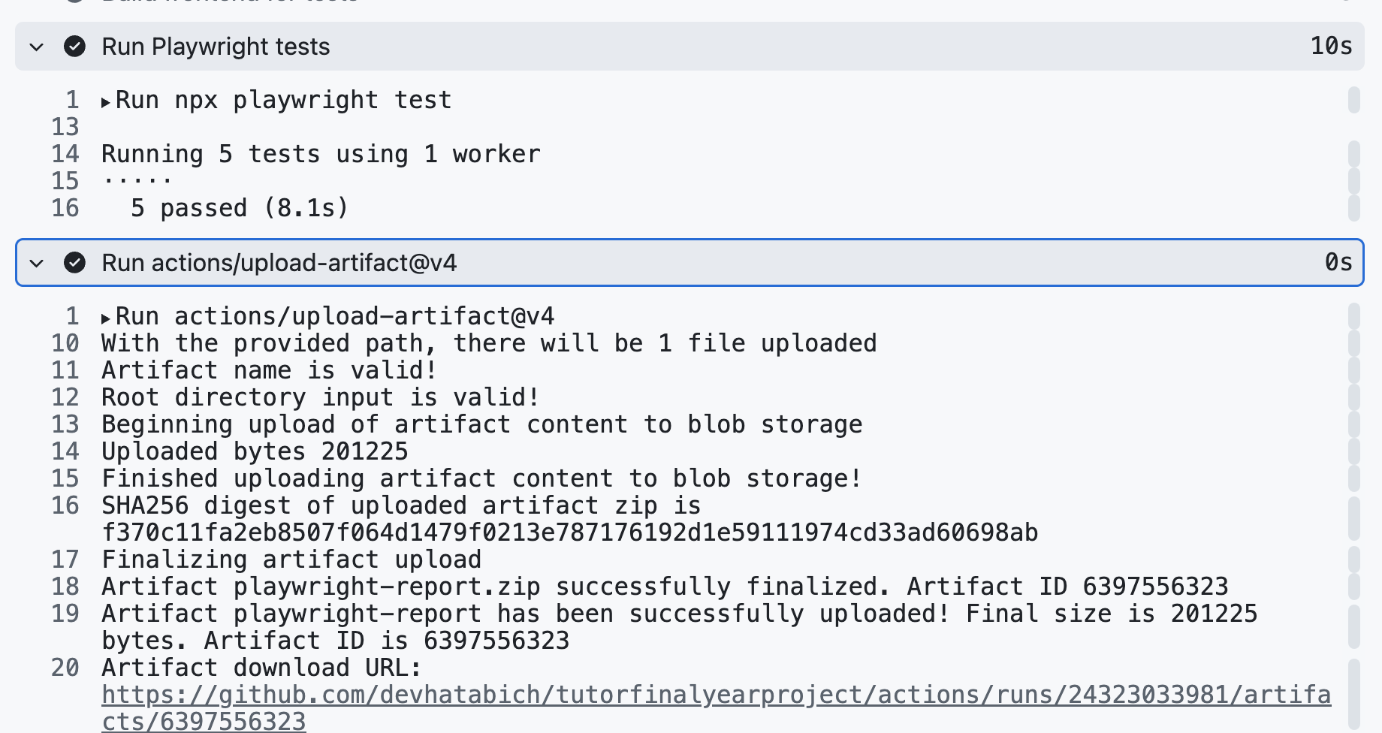
Figure A.24: Github Actions running frontend Playwright tests successfully
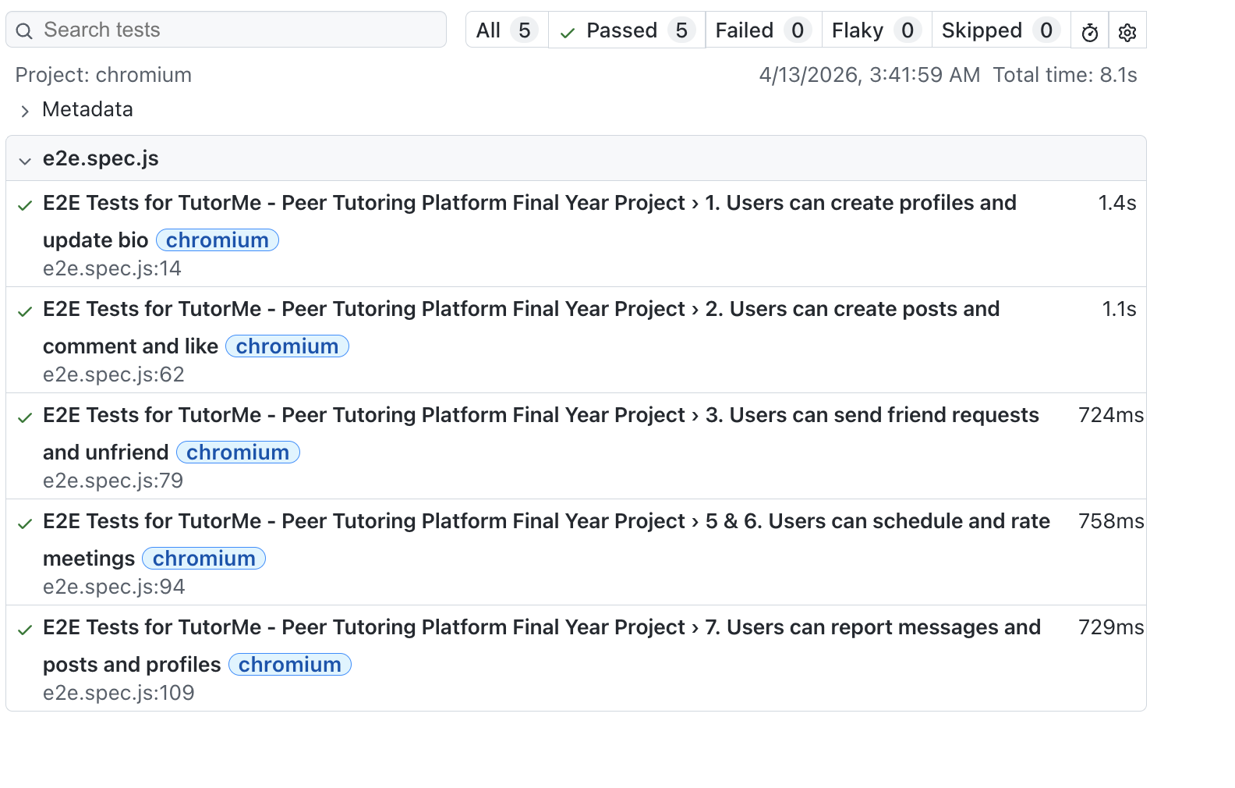
Figure A.25: Playwright HTML report overview

Appendix B: Backend Jest Test Evidence
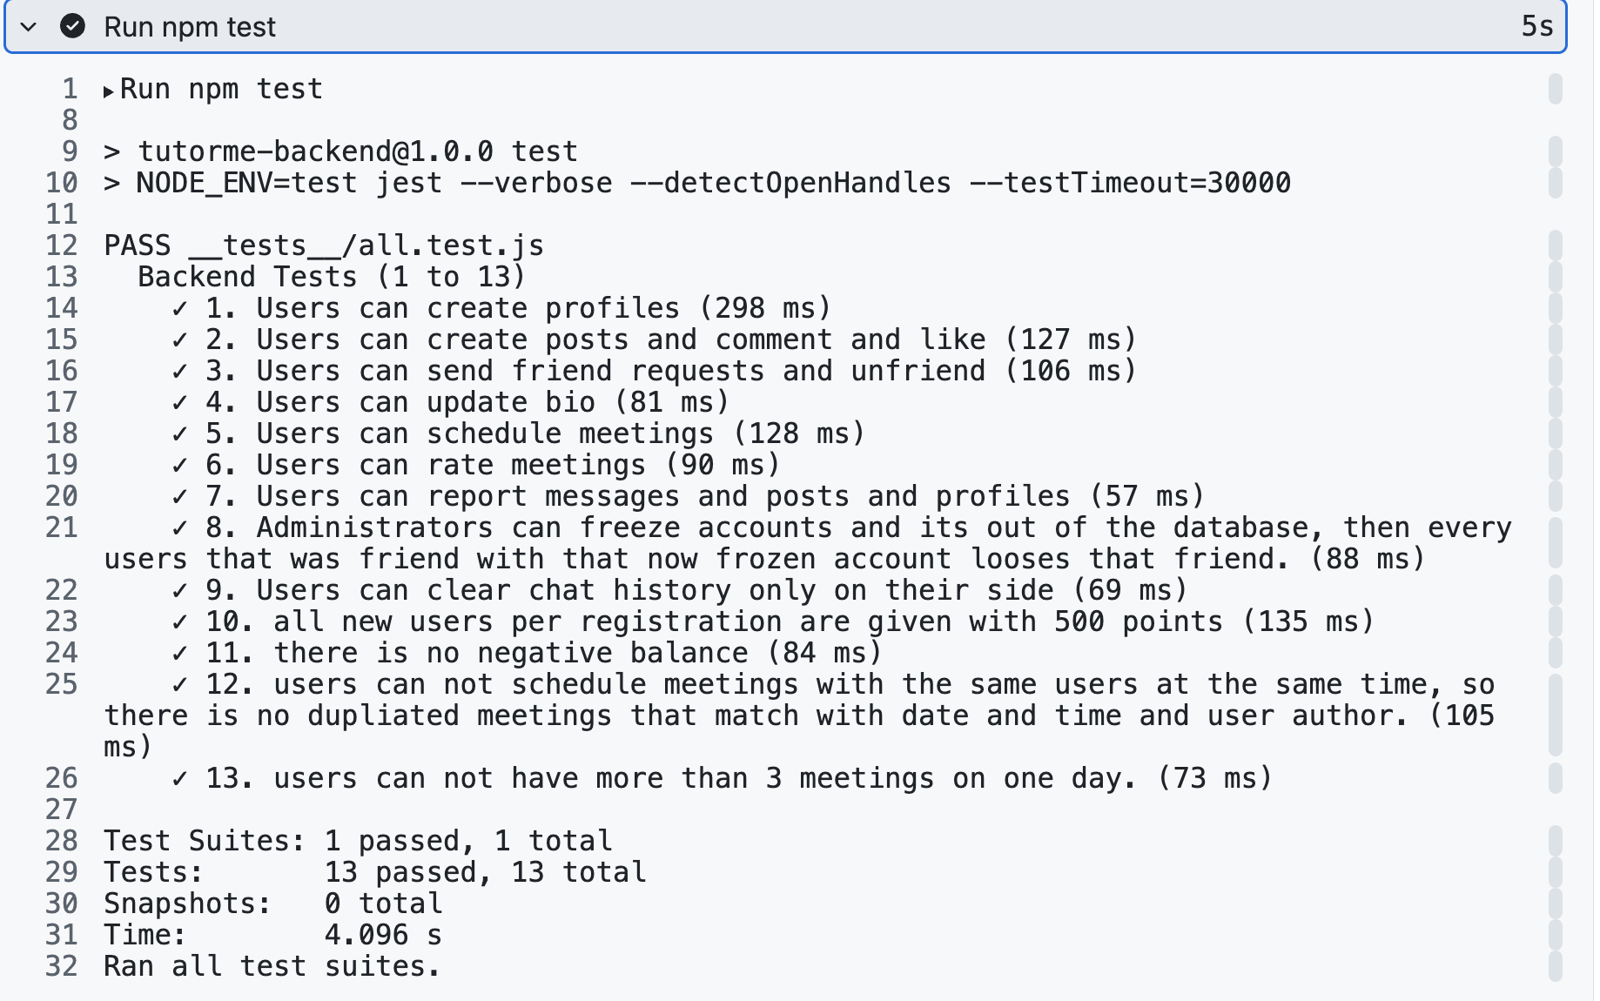
Figure B.26: Github Actions running backend Jest tests successfully

Appendix C: Github Actions CI/CD Workflow

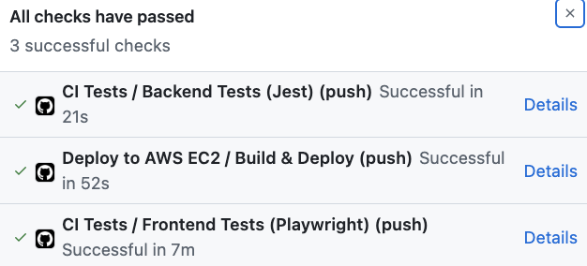
Figure C.27: Github Actions workflow showing all checks including Backend Tests, Deployment to AWS EC2 and Frontend tests have passed after a commit to main branch

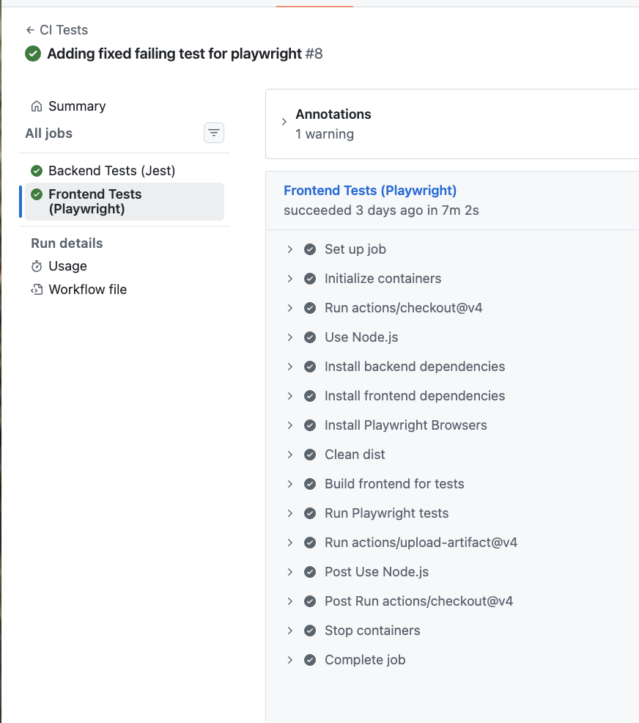
Figure C.28: Github Actions workflow showing that Frontend Tests were executed successfully

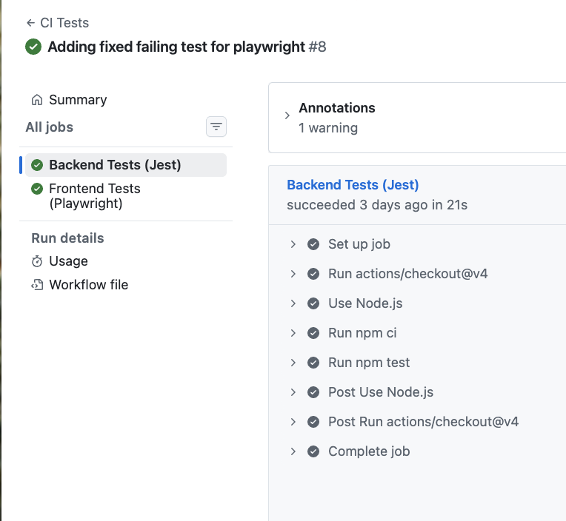
Figure C.29: Github Actions workflow showing that Backend Tests were executed successfully
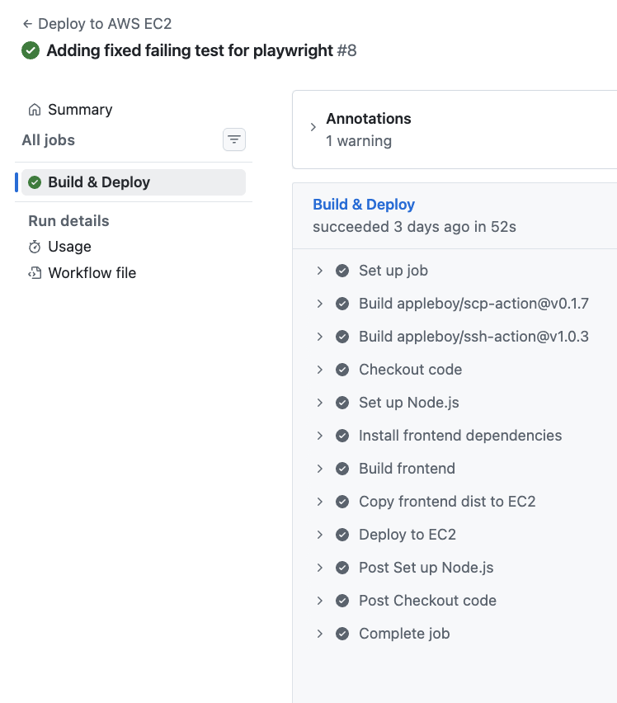
Figure C.30: Github Actions workflow showing that AWS EC2 Deployment was executed successfully

